# CSA0683-DESIGN AND ANALYSIS OF ALGORITHMS FOR SEARCHING ALGORITHMS

**B.Nikhil(192111054)**

**DAY-1**

1. **Write a C program to Print Fibonacci Series using recursion PROGRAM**

#include<stdio.h> #include<conio.h> int fibonacci(int); int main(){

int n, i;

printf("Enter the number of element you want in series :"); scanf("%d",&n);

printf("fibonacci series is : \n"); for(i=0;i<n;i++) {

printf("%d \n",fibonacci(i));

}

getch();

}

int fibonacci(int i){

if(i==0) return 0; else if(i==1) return 1;

else return (fibonacci(i-1)+fibonacci(i-2));

}

**OUTPUT :**

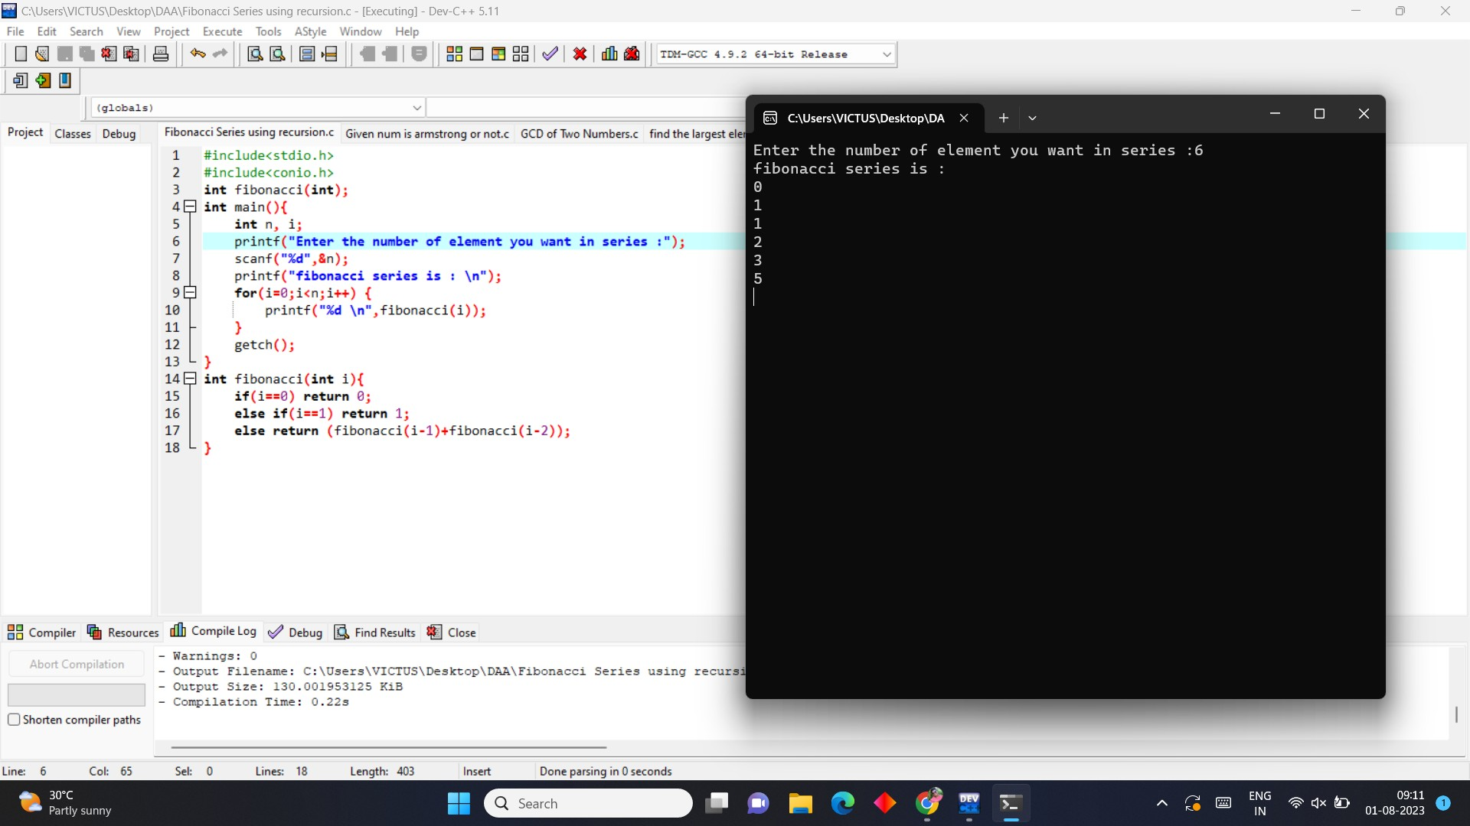

1. **Write a C program to check if the given no is Armstrong or not.**

**PROGRAM:**

#include<stdio.h> int main()

{

int n,r,sum=0,temp; printf("enter the number="); scanf("%d",&n);

temp=n; while(n>0)

{ r=n%10;

sum=sum+(r*r*r); n=n/10;

}

if(temp==sum) printf("armstrong number "); else

printf("not armstrong number"); return 0;

}

**OUTPUT:**

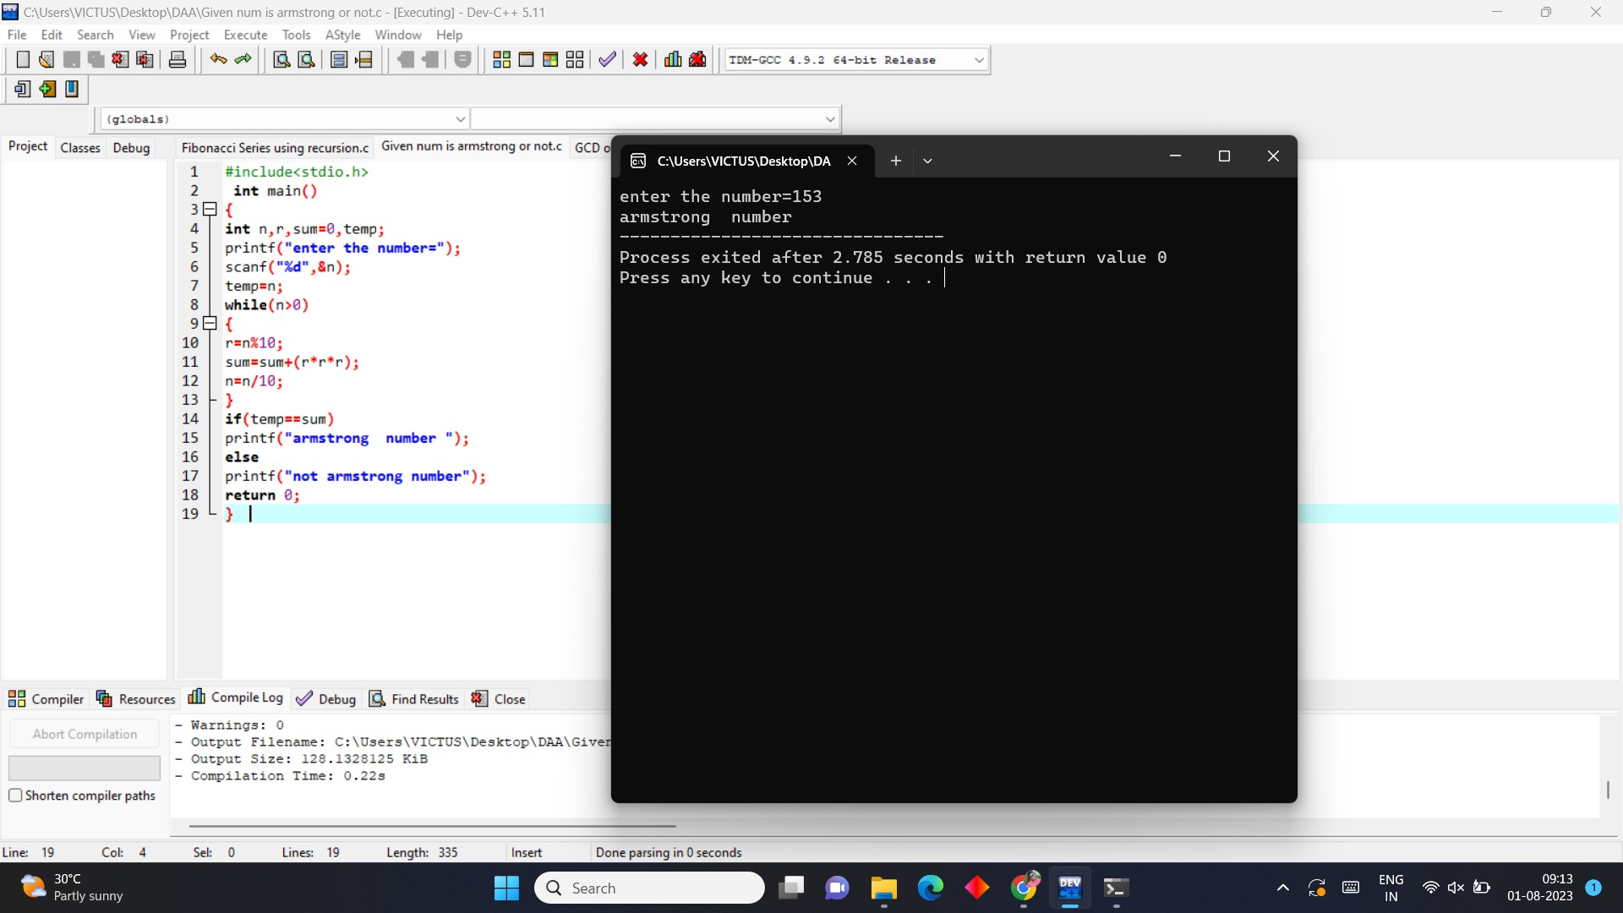

1. **Write a C program to find the GCD of two numbers .**

**PROGRAM:**

#include <stdio.h> int main()

{

int Num1, Num2, i, GCD;

printf("Please Enter two integer Values \n"); scanf("%d %d", &Num1, &Num2);

for(i = 1; i <= Num1 && i <= Num2; i++)

{

if(Num1 % i == 0 && Num2 % i == 0) GCD = i;

}

printf("GCD of %d and %d is = %d", Num1, Num2, GCD); return 0;

}

**OUTPUT :**

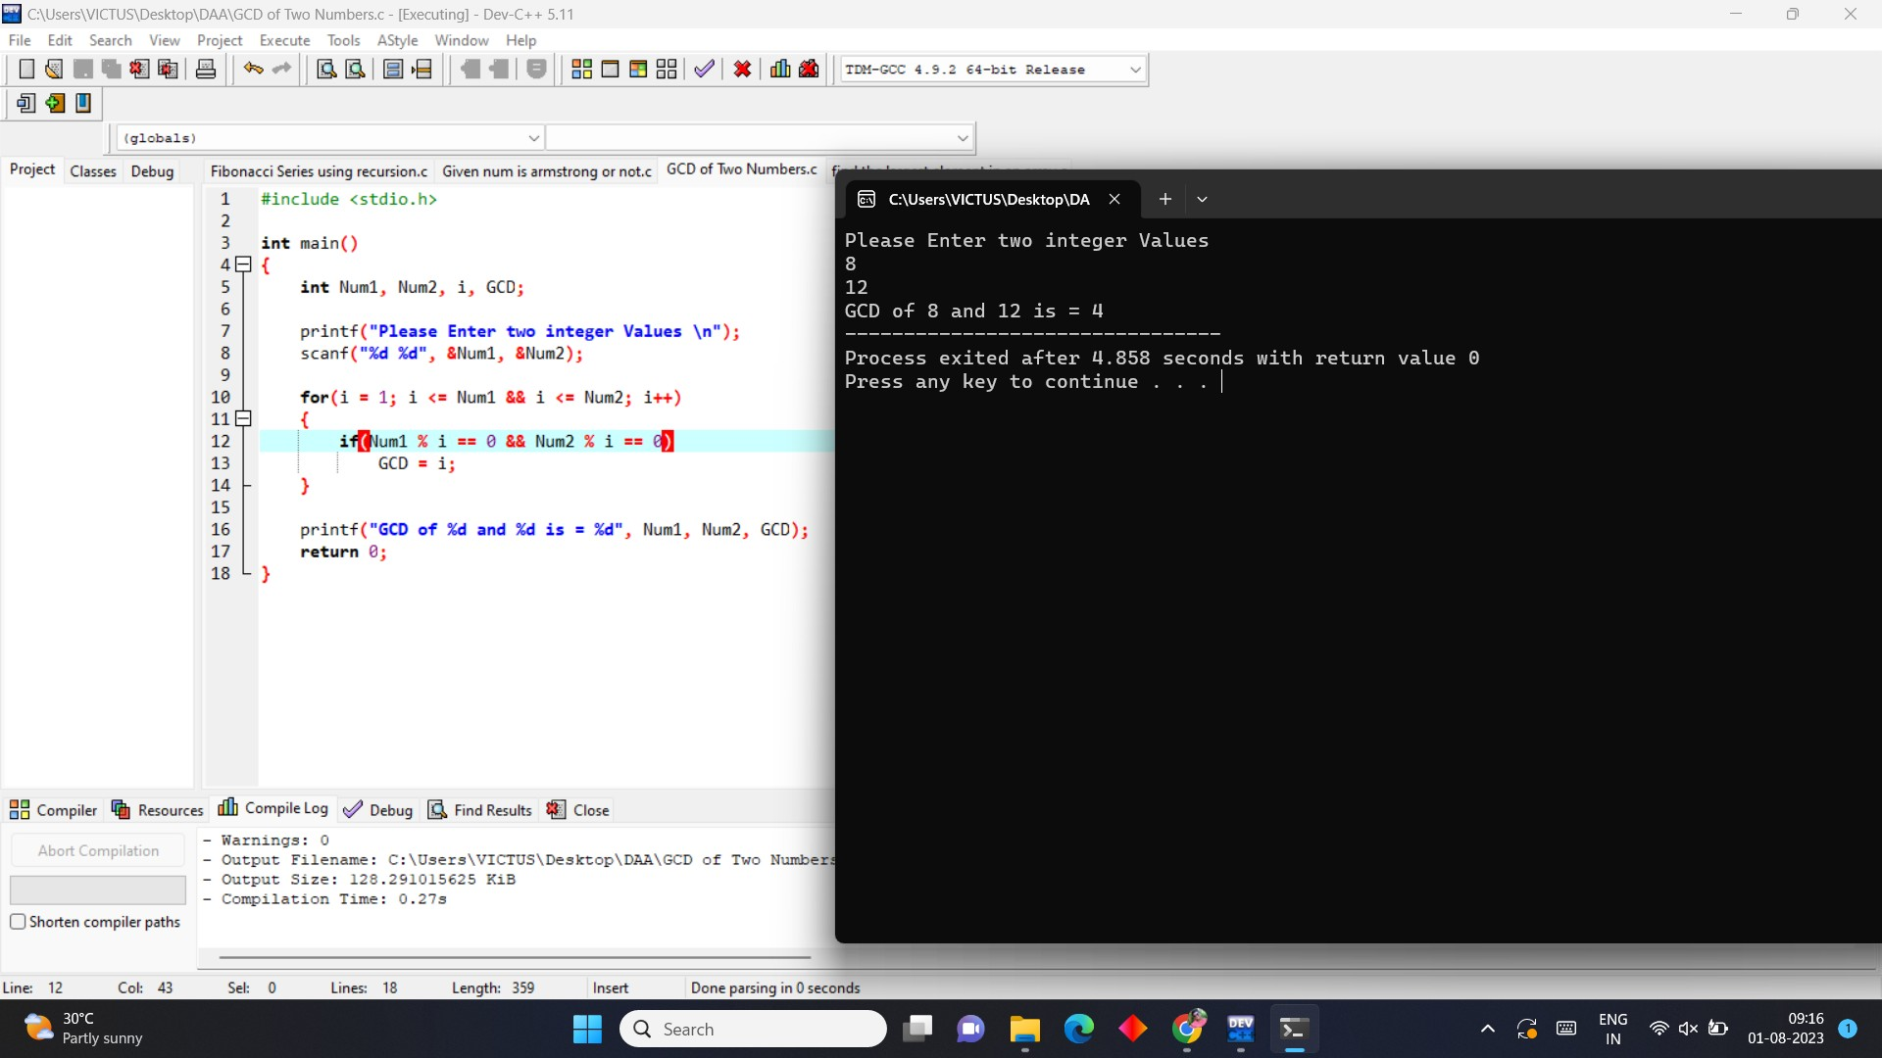

1. **Write a C program to get the largest element of an array.**

**PROGRAM**

#include<stdio.h> #include<conio.h> int main()

{

int arr[10], i, large;

printf("Enter 10 Array Elements: "); for(i=0; i<10; i++)

scanf("%d", &arr[i]); i=0;

large = arr[i]; while(i<10)

{

if(large<arr[i]) large = arr[i];

i++;

}

printf("\nLargest Number = %d", large); getch();

return 0;

}

**OUTPUT**

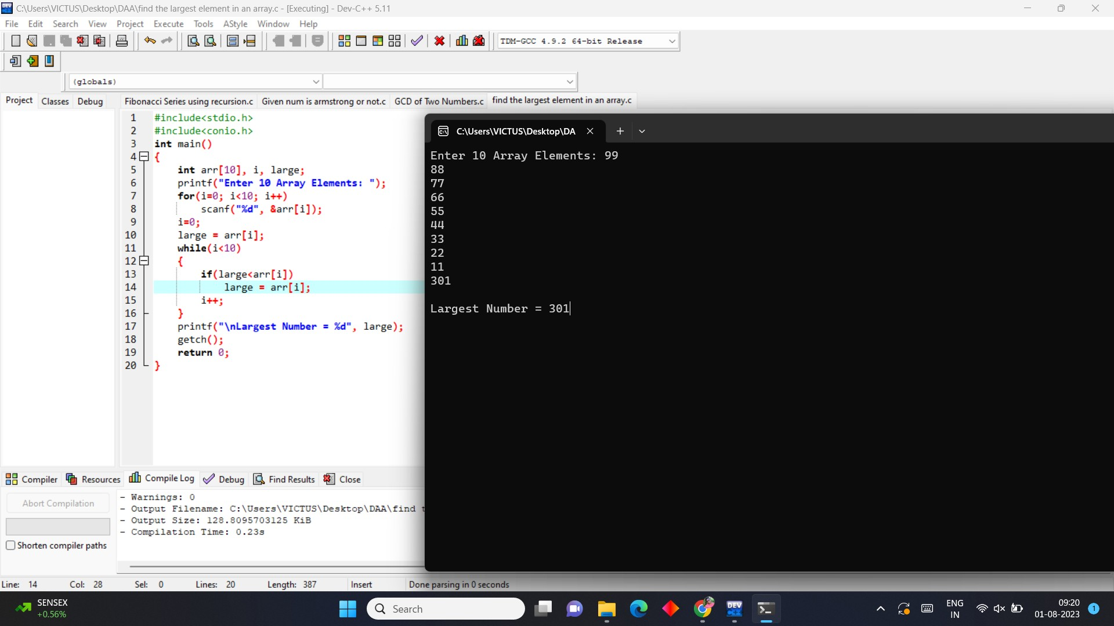

1. **Write a C program to find the Factorial of a number .**

**PROGRAM**

#include<stdio.h> int main()

{

int i,fact=1,number; printf("Enter a number: "); scanf("%d",&number);

for(i=1;i<=number;i++){ fact=fact*i;

}

printf("Factorial of %d is: %d",number,fact); return 0;

}

**OUTPUT**

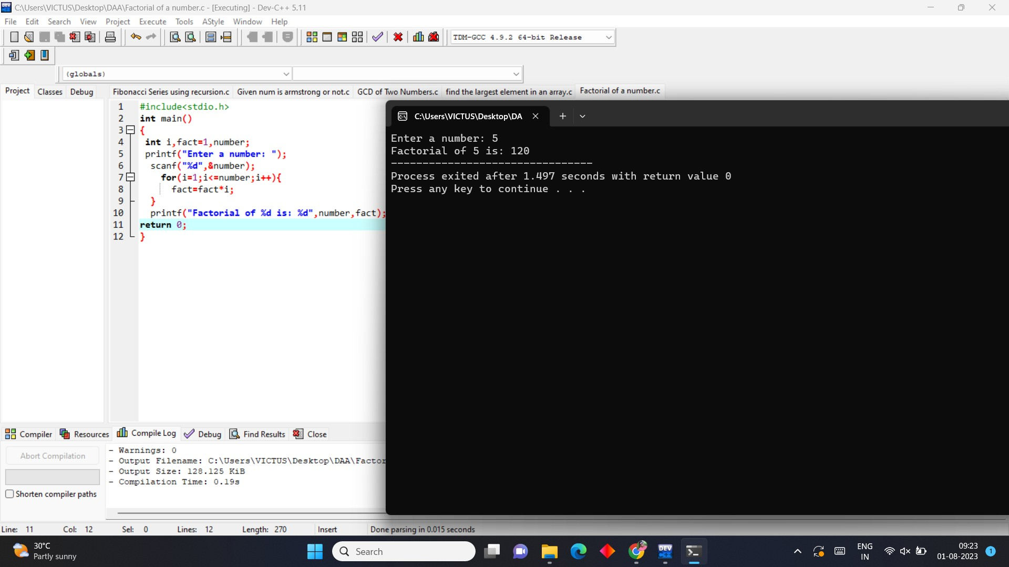

1. **Write a C program to check if a number is a prime number or not .**

**PROGRAM**

#include <stdio.h> int main()

{

int n, i, c = 0;

printf("Enter any number n:"); scanf("%d", &n);

for (i = 1; i <= n; i++)

{

if (n % i == 0)

{ c++;

}

}

if (c == 2)

{

printf("n is a Prime number");

}

else

{

printf("n is not a Prime number");

}

return 0;

}

**OUTPUT**

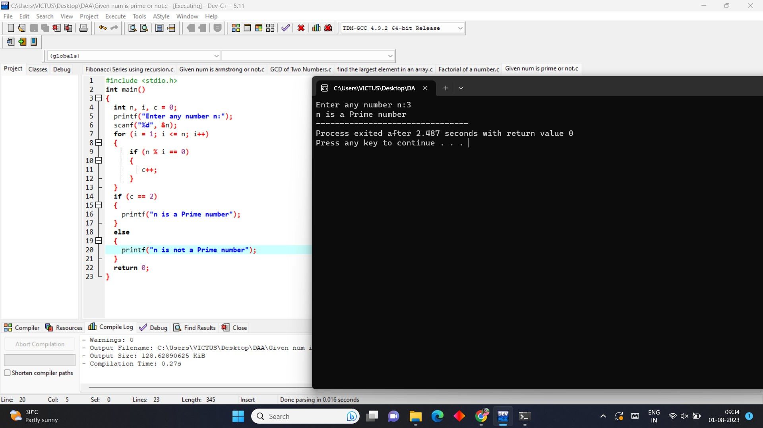

1. **Write a C program to perform Selection sort.**

**PROGRAM**

#include <stdio.h> int main()

{

int arr[10]={6,12,0,18,11,99,55,45,34,2};

int n=10;

int i, j, position, swap; for (i = 0; i < (n - 1); i++)

{

position = i;

for (j = i + 1; j < n; j++)

{

if (arr[position] > arr[j]) position = j;

}

if (position != i)

{

swap = arr[i];

arr[i] = arr[position]; arr[position] = swap;

}

}

for (i = 0; i < n; i++) printf("%d\t", arr[i]);

return 0;

}

**OUTPUT**

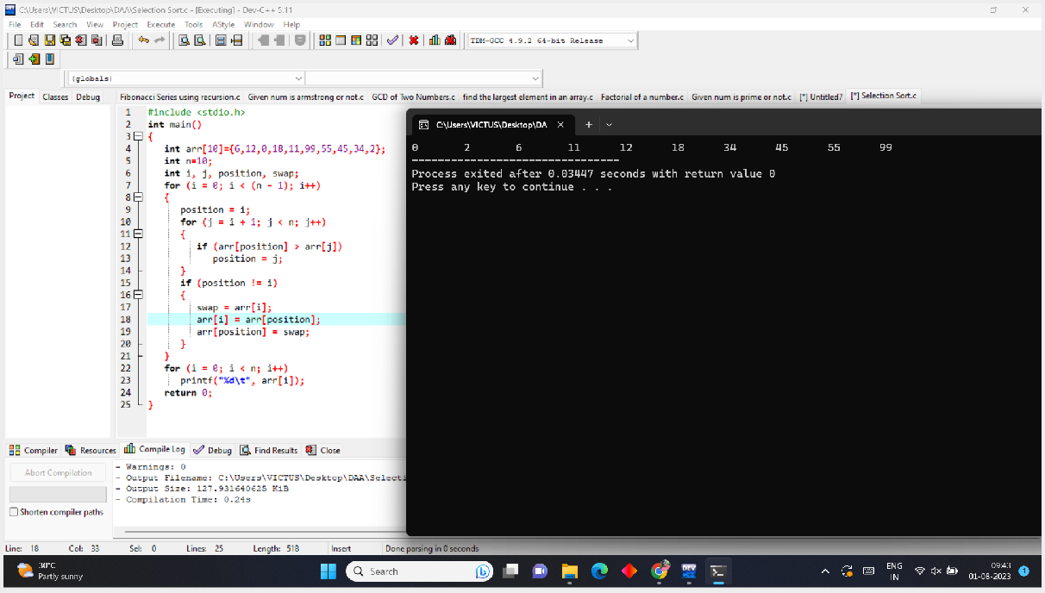

1. **Write a C program to perform Bubble sort**

**PROGRAM**

#include <stdio.h> int main()

{

int array[100], n, c, d, swap; printf("Enter number of elements\n"); scanf("%d", &n);

printf("Enter %d integers\n", n); for (c = 0; c < n; c++) scanf("%d", &array[c]);

for (c = 0 ; c < n - 1; c++)

{

for (d = 0 ; d < n - c - 1; d++)

{

if (array[d] > array[d+1])

{

swap = array[d]; array[d] = array[d+1]; array[d+1] = swap;

}

}

**}**

printf("Sorted list in ascending order:\n");

for (c = 0; c < n; c++) printf("%d\n", array[c]);

return 0;

}

**OUTPUT**

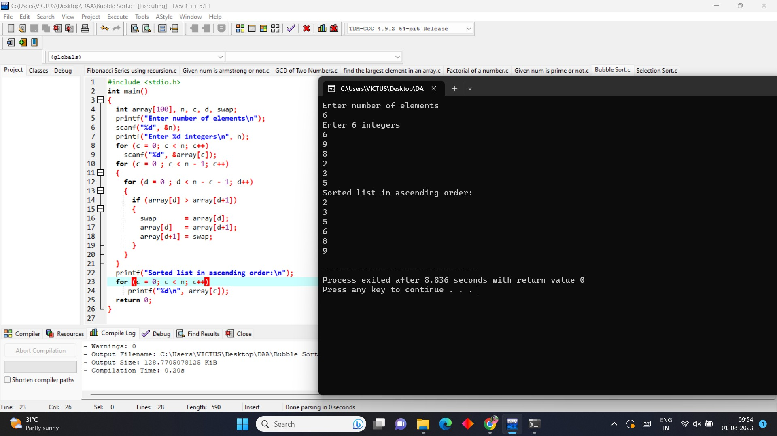

1. **Write a C program to multiply two Matrix PROGRAM**

#include<stdio.h> int main()

{

int a[10][10], b[10][10], c[10][10], n, i, j, k;

printf("Enter the value of N (N <= 10): "); scanf("%d", & n);

printf("Enter the elements of Matrix-A: \n"); for (i = 0; i < n; i++)

{

for (j = 0; j < n; j++)

{

scanf("%d", & a[i][j]);

}

}

printf("Enter the elements of Matrix-B: \n"); for (i = 0; i < n; i++)

{

for (j = 0; j < n; j++)

{

scanf("%d", & b[i][j]);

}

}

for (i = 0; i < n; i++)

{

for (j = 0; j < n; j++)

{ c[i][j] = 0;

for (k = 0; k < n; k++)

{

c[i][j] += a[i][k] * b[k][j];

}

}

}

printf("The product of the two matrices is: \n"); for (i = 0; i < n; i++)

{

for (j = 0; j < n; j++)

{

printf("%d\t", c[i][j]);

}

printf("\n");

}

return 0;

}

**OUTPUT**

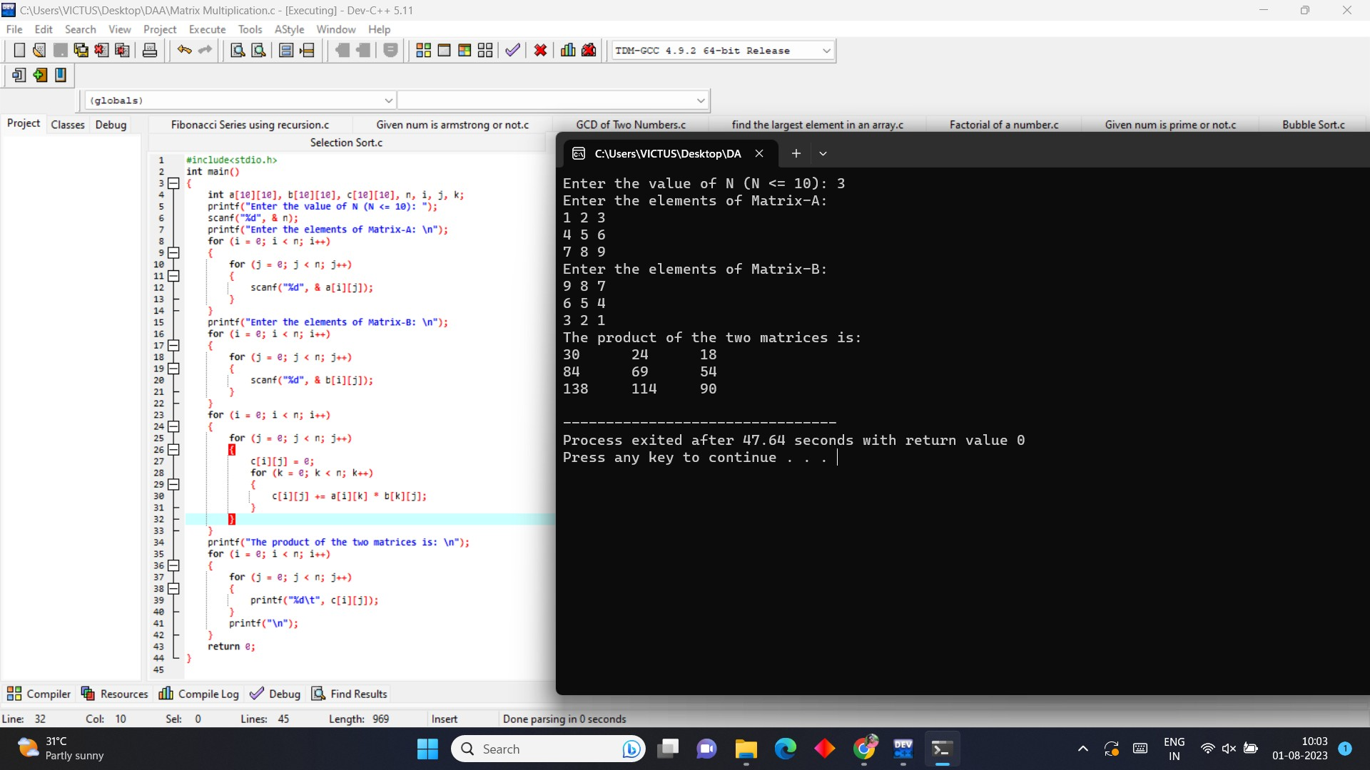

1. **Write a C program for to check whether a given String is Palindrome or not**

**PROGRAM**

#include<stdio.h> int main()

{

int n,r,sum=0,temp; printf("enter="); scanf("%d",&n); temp=n; while(n>0)

{

r=n%10;

sum=(sum*10)+r; n=n/10;

}

if(temp==sum) printf("palindrome"); else

printf("not palindrome"); return 0;

}

**OUTPUT**

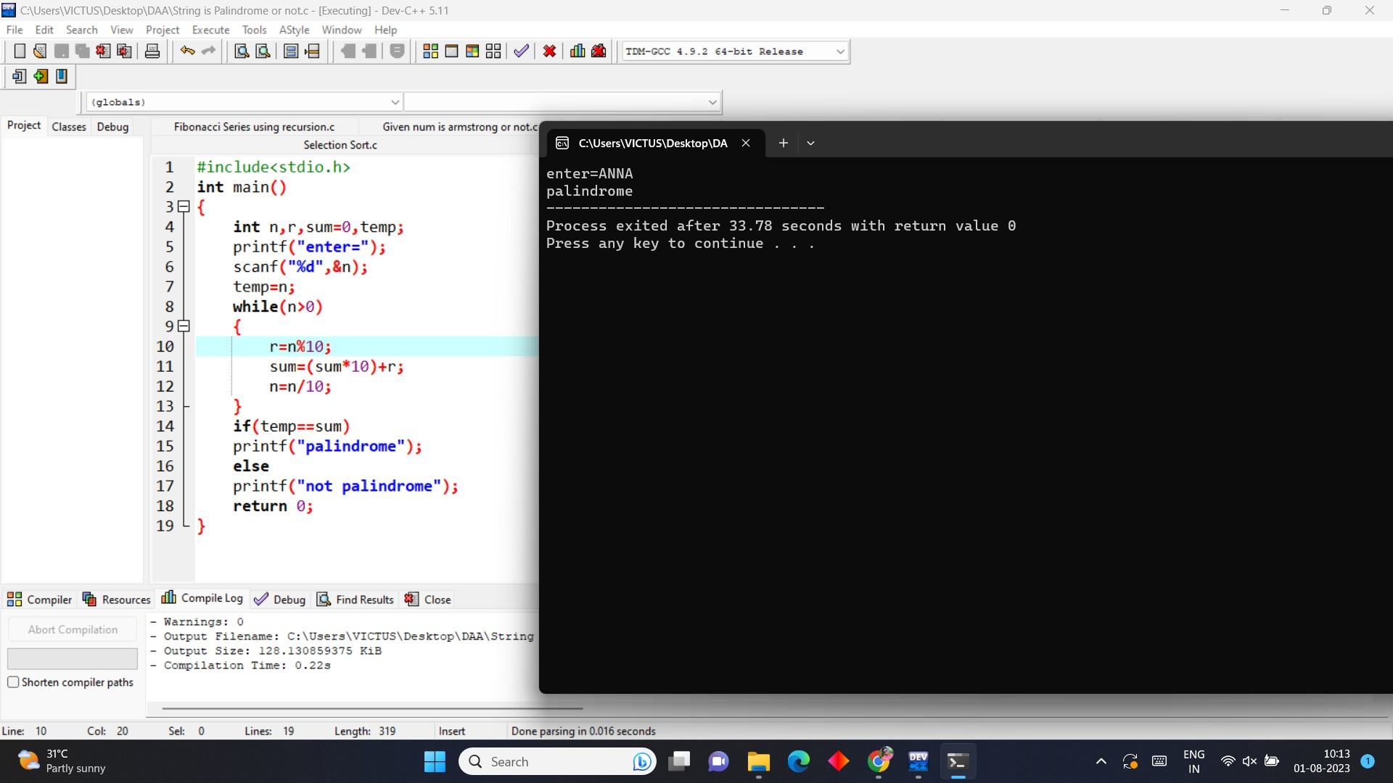

1. **Write a C program to copy one string to another PROGRAM**

#include<stdio.h>

#include<conio.h> #include<string.h> int main()

{

char str1[20], str2[20]; printf("Enter the string: "); gets(str1);

printf("\nString 1 = %s", str1); strcpy(str2, str1); printf("\nString 2 = %s", str2); getch();

return 0;

}

**OUTPUT**

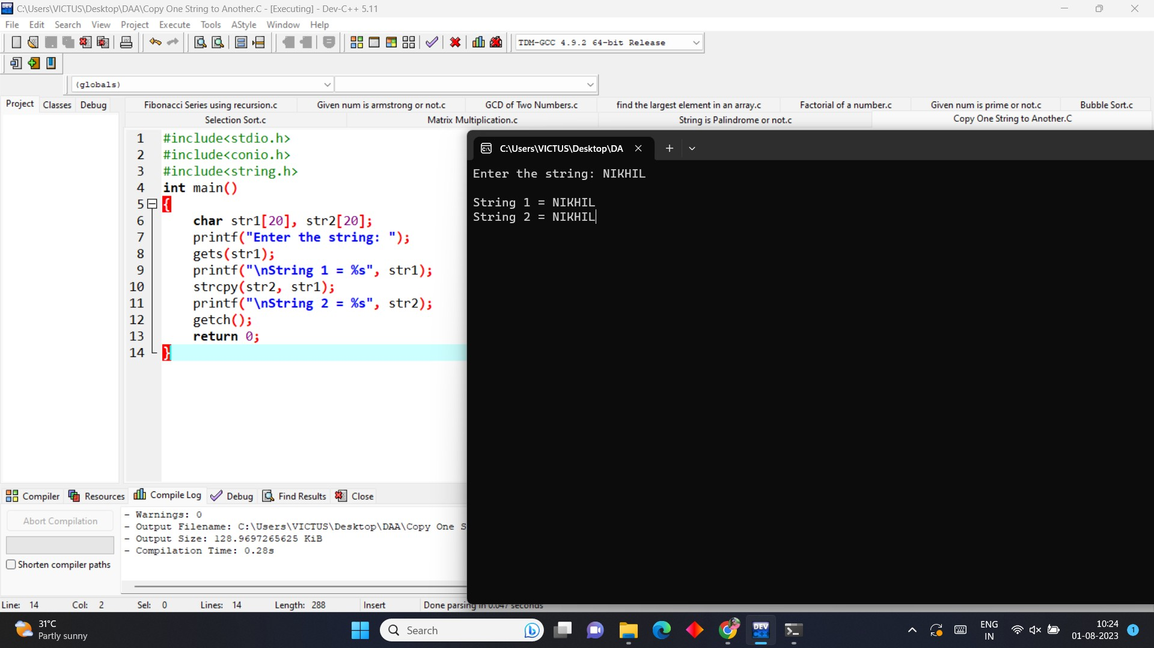

1. **Write a Program to perform binary search.**

**PROGRAM**

#include <stdio.h> int main()

{

int c, first, last, middle, n, search, array[100]; printf("Enter number of elements\n"); scanf("%d", &n);

printf("Enter %d integers\n", n); for (c = 0; c < n; c++)

scanf("%d", &array[c]); printf("Enter value to find\n"); scanf("%d", &search);

first = 0; last = n - 1;

middle = (first+last)/2; while (first <= last)

{

if (array[middle] < search) first = middle + 1;

else if (array[middle] == search)

{

printf("%d found at location %d.\n", search, middle+1); break;

}

else

last = middle - 1; middle = (first + last)/2;

}

if (first > last)

printf("Not found! %d isn't present in the list.\n", search); return 0;

}

**OUTPUT**

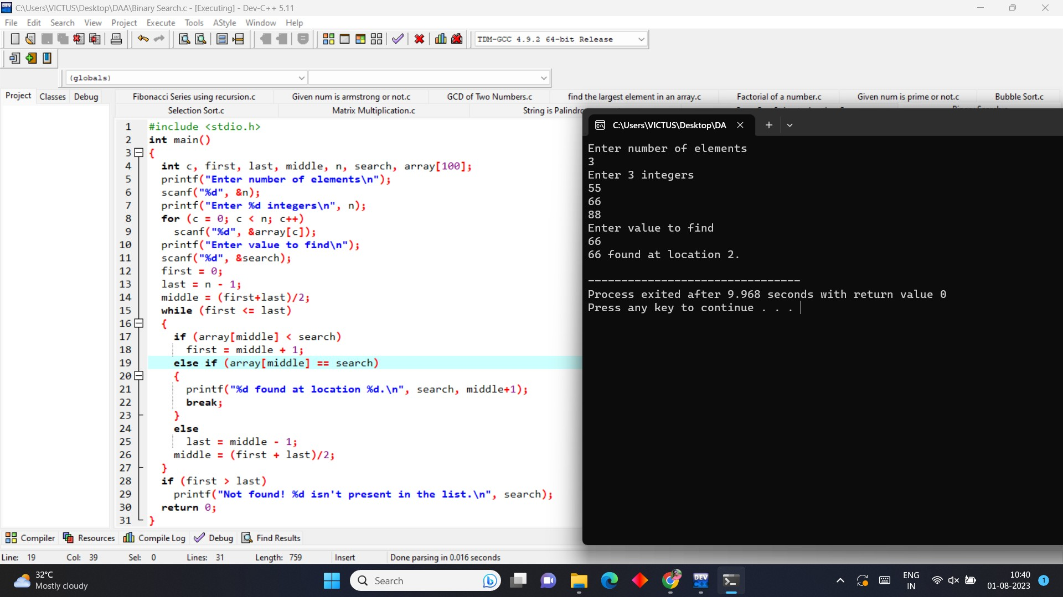

1. **Write a program to print the reverse of a string**

**PROGRAM:**

#include <stdio.h> #include <string.h> int main()

{

char str[40];

printf (" \n Enter a string to be reversed: "); scanf ("%s", str);

printf (" \n After the reverse of a string: %s ", strrev(str)); return 0;

}

**OUTPUT**

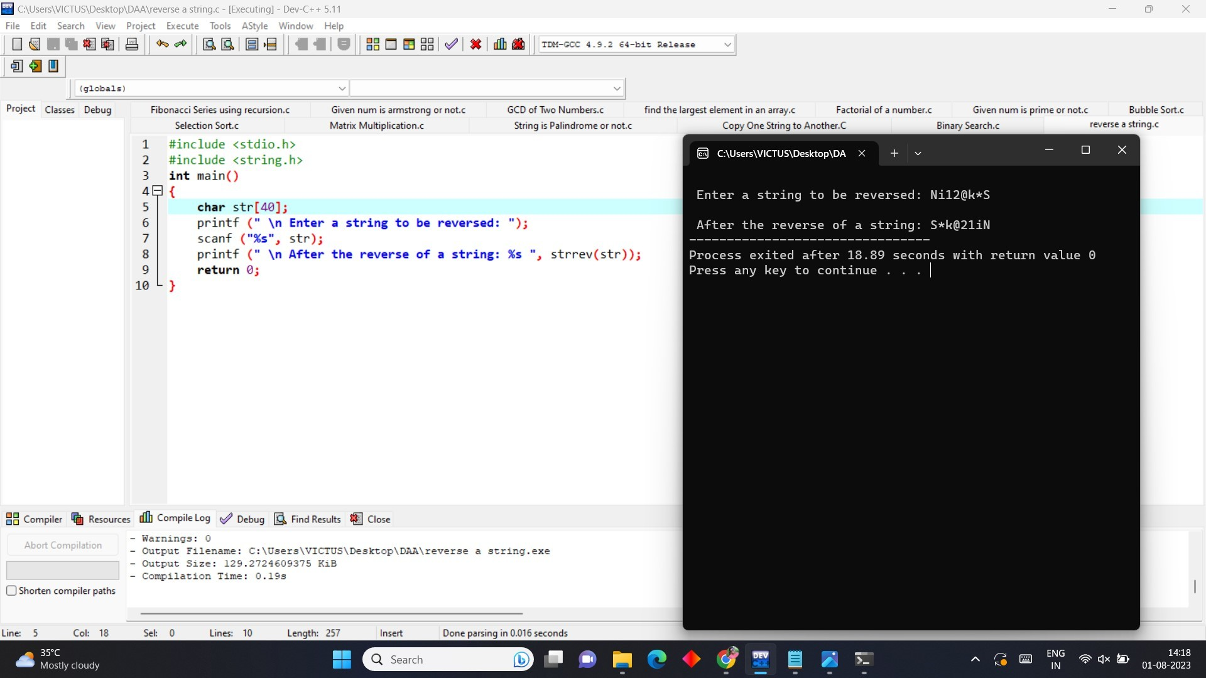

1. **Write a program to find the length of a string.**

**PROGRAM**

#include <stdio.h> int main() {

char s[] = "Good Morning"; int i;

for (i = 0; s[i] != '\0'; ++i);

printf("Length of the string: %d", i); return 0;

}

**OUTPUT**

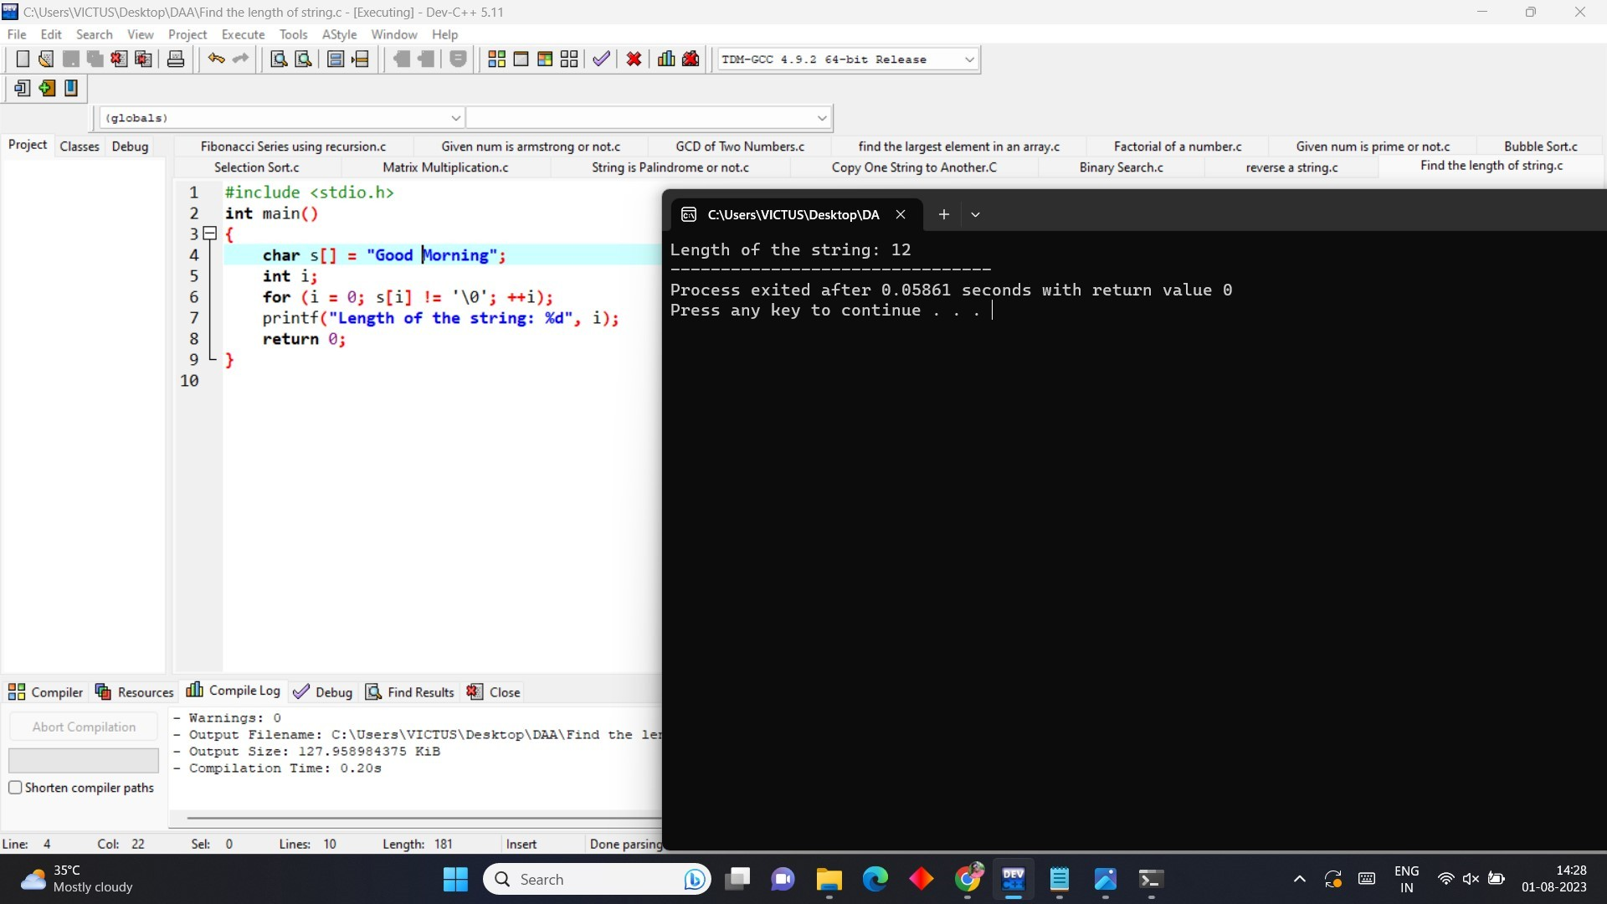

1. **Write a program to perform Strassen’s Matrix Multiplication.**

**PROGRAM**

#include<stdio.h> int main(){

int a[2][2], b[2][2], c[2][2], i, j;

int m1, m2, m3, m4 , m5, m6, m7;

printf("Enter the 4 elements of first matrix: "); for(i = 0;i < 2; i++)

for(j = 0;j < 2; j++) scanf("%d", &a[i][j]);

printf("Enter the 4 elements of second matrix: "); for(i = 0; i < 2; i++)

for(j = 0;j < 2; j++) scanf("%d", &b[i][j]);

printf("\nThe first matrix is\n"); for(i = 0; i < 2; i++){

printf("\n");

for(j = 0; j < 2; j++) printf("%d\t", a[i][j]);

}

printf("\nThe second matrix is\n");

for(i = 0;i < 2; i++){ printf("\n");

for(j = 0;j < 2; j++) printf("%d\t", b[i][j]);

}

m1= (a[0][0] + a[1][1]) * (b[0][0] + b[1][1]);

m2= (a[1][0] + a[1][1]) * b[0][0];

m3= a[0][0] * (b[0][1] - b[1][1]);

m4= a[1][1] * (b[1][0] - b[0][0]);

m5= (a[0][0] + a[0][1]) * b[1][1];

m6= (a[1][0] - a[0][0]) * (b[0][0]+b[0][1]);

m7= (a[0][1] - a[1][1]) * (b[1][0]+b[1][1]);

c[0][0] = m1 + m4- m5 + m7; c[0][1] = m3 + m5;

c[1][0] = m2 + m4;

c[1][1] = m1 - m2 + m3 + m6;

printf("\nAfter multiplication using Strassen's algorithm \n"); for(i = 0; i < 2 ; i++){

printf("\n");

for(j = 0;j < 2; j++) printf("%d\t", c[i][j]);

}

return 0;

}

**OUTPUT**

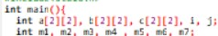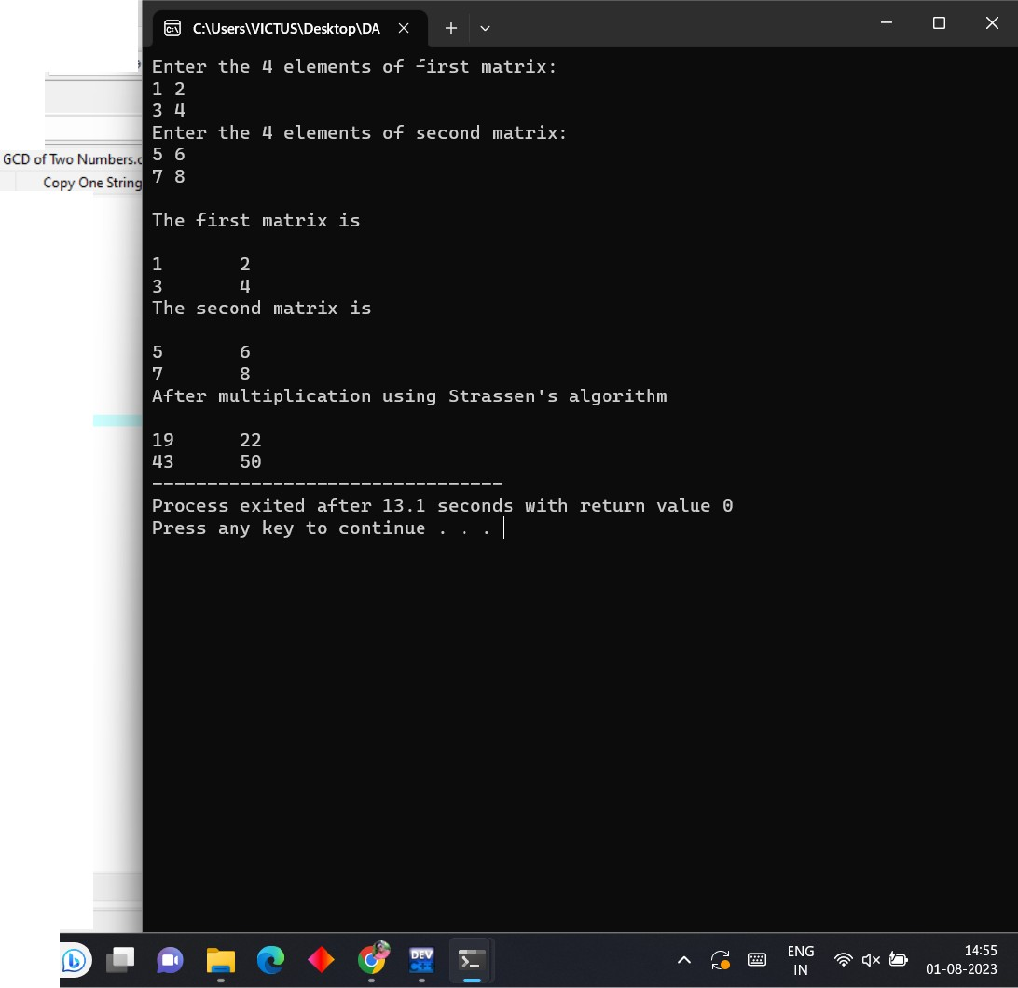

**lijil** C:\Users\VICTUS\Ceslctop\DAA\St·assen Matrix Multiplication.cpJ - [Executing) - Dev-C+ + 5.11

I□@I ■IIPl!lIII""..II19.19.-l E3JJ **ti t11 a1**g**1**g□ 88lsll II I **dHiJI** rn•-= u

_!]j]

File Edrt Search View Project Execute Tools AS e Window Help

J 111lob•h)

Project Clas es Debug Fibonacci Series using recur;ion.c Given num is ummong ornot.c ectionSort.c MatrixW.ultiplication.c StringisPalindromeornot.c

prlott("(MM u... •L-u Of tl;U .. ,,u, ");

<..-(L • l;I < l; h+)

(!J;r::::: ! \:"Of -- uteh ");

u...t("M", Utll[Jll;

prlott("\l,TIMlt1,., .. 1eu ll\11"):

<..-(L•I; I< l; h+I{

p;lalf("V,"),

fo,{l•I; J < l; J++)

p.-Jlllf("M\t', •llJ(JJ);

...0. .;.!;1.;. :l:ilum,

pr!atl("\•Toeoe<- .. t•bU\•"):

-(I• l:1 < l; h•)\

"

;• ·;•:?: l; !++)

prllllf{"M\t·. tl!J(JI);

:!:1:1rn:1: :1:n:1::mm 1· 111111u,

n _., •l!Jtl) • (t(l)lll • t[l]<IJ);

**ah •[11(1)** • (t(l)tJI • tp][IIJ:

::1:1rni:1·:nmw: 1i ;.•,,1tl]),

" 1:m1: :::-; -7,

•7• (•ll]l!J · •(l)tJI) • (t(l)ll]•t(!)tl]);

"

<l!Jtl) ••I· al ••I••;

·r:,a:'t, l !!W'u..**..1.ot***W••-··* 1,.,.\•");

p;l•U("V,");

fw(l•l;Jcl;J++J prllllf{"M\t", <l!JtJIH

<l!Jtl)•al•_.:

" I

88 Compiler **'ii** Resources d1b Compil Log If' Debug [g Find Results

Donepusingin0.01Sseconds

Q Search

# CSA0683-DESIGN AND ANALYSIS OF ALGORITHMS FOR SEARCHING ALGORITHMS

**B.Nikhil(192111054)**

**DAY-2**

1. **Write a program to perform MST using greedy techniques.**

**PROGRAM**

#include<stdio.h> #include<conio.h> int a,b,u,v,n,i,j,ne=1; int visited[10]= {

0

}

,min,mincost=0,cost[10][10]; void main() {

clrscr();

printf("\n Enter the number of nodes:"); scanf("%d",&n);

printf("\n Enter the adjacency matrix:\n"); for (i=1;i<=n;i++)

for (j=1;j<=n;j++) {

scanf("%d",&cost[i][j]); if(cost[i][j]==0)

cost[i][j]=999;

}

visited[1]=1; printf("\n"); while(ne<n) {

for (i=1,min=999;i<=n;i++) for (j=1;j<=n;j++) if(cost[i][j]<min)

if(visited[i]!=0) {

min=cost[i][j]; a=u=i;

b=v=j;

}

if(visited[u]==0 || visited[v]==0) {

printf("\n Edge %d:(%d %d) cost:%d",ne++,a,b,min); mincost+=min;

visited[b]=1;

}

cost[a][b]=cost[b][a]=999;

}

printf("\n Minimun cost=%d",mincost); getch();

}

**OUTPUT**

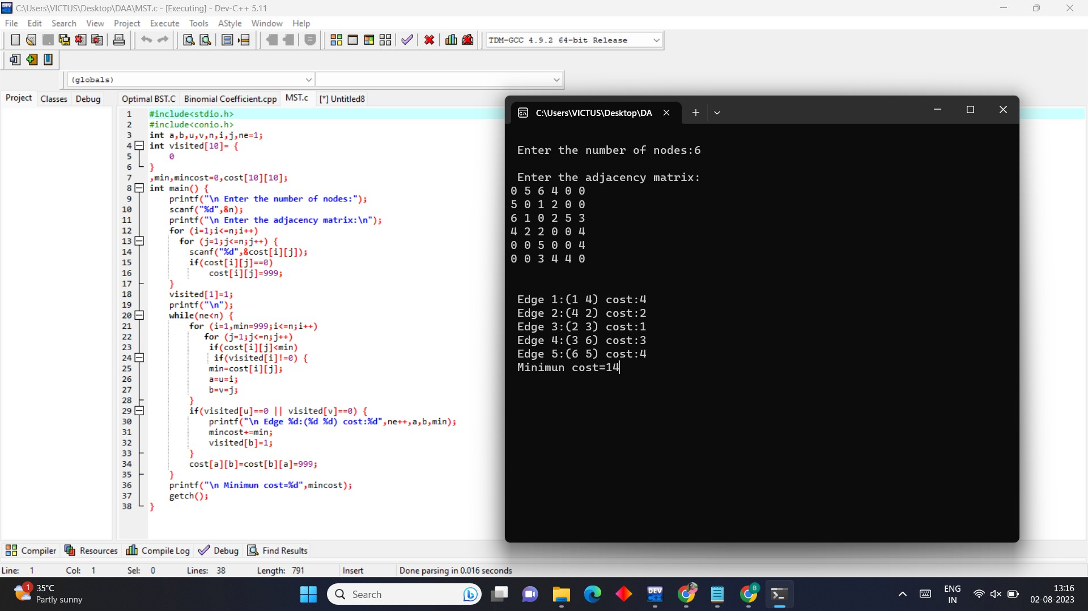

1. **Using Dynamic programming concepts to find out the Optimal binary search tree PROGRAM**

#include <stdio.h> #include <limits.h>

double sumProbabilities(double probabilities[], int start, int end) { double sum = 0.0;

for (int i = start; i <= end; i++) sum += probabilities[i];

return sum;

}

double optimalBSTCost(double keys[], double probabilities[], int n) { double dp[n][n];

for (int i = 0; i < n; i++) dp[i][i] = probabilities[i];

for (int L = 2; L <= n; L++) {

for (int i = 0; i <= n - L + 1; i++) { int j = i + L - 1;

dp[i][j] = INT_MAX;

for (int r = i; r <= j; r++) {

double cost = ((r > i) ? dp[i][r - 1] : 0) + ((r < j) ? dp[r + 1][j] : 0) + sumProbabilities(probabilities, i, j);

if (cost < dp[i][j])

dp[i][j] = cost;

}

}

}

return dp[0][n - 1];

}

int main()

{

int n;

printf("Enter the number of keys: "); scanf("%d", &n);

double keys[n], probabilities[n];

printf("Enter the keys and their probabilities:\n"); for (int i = 0; i < n; i++) {

scanf("%lf %lf", &keys[i], &probabilities[i]);

}

double cost = optimalBSTCost(keys, probabilities, n); printf("Optimal BST cost: %lf\n", cost);

return 0;

}

**OUTPUT**

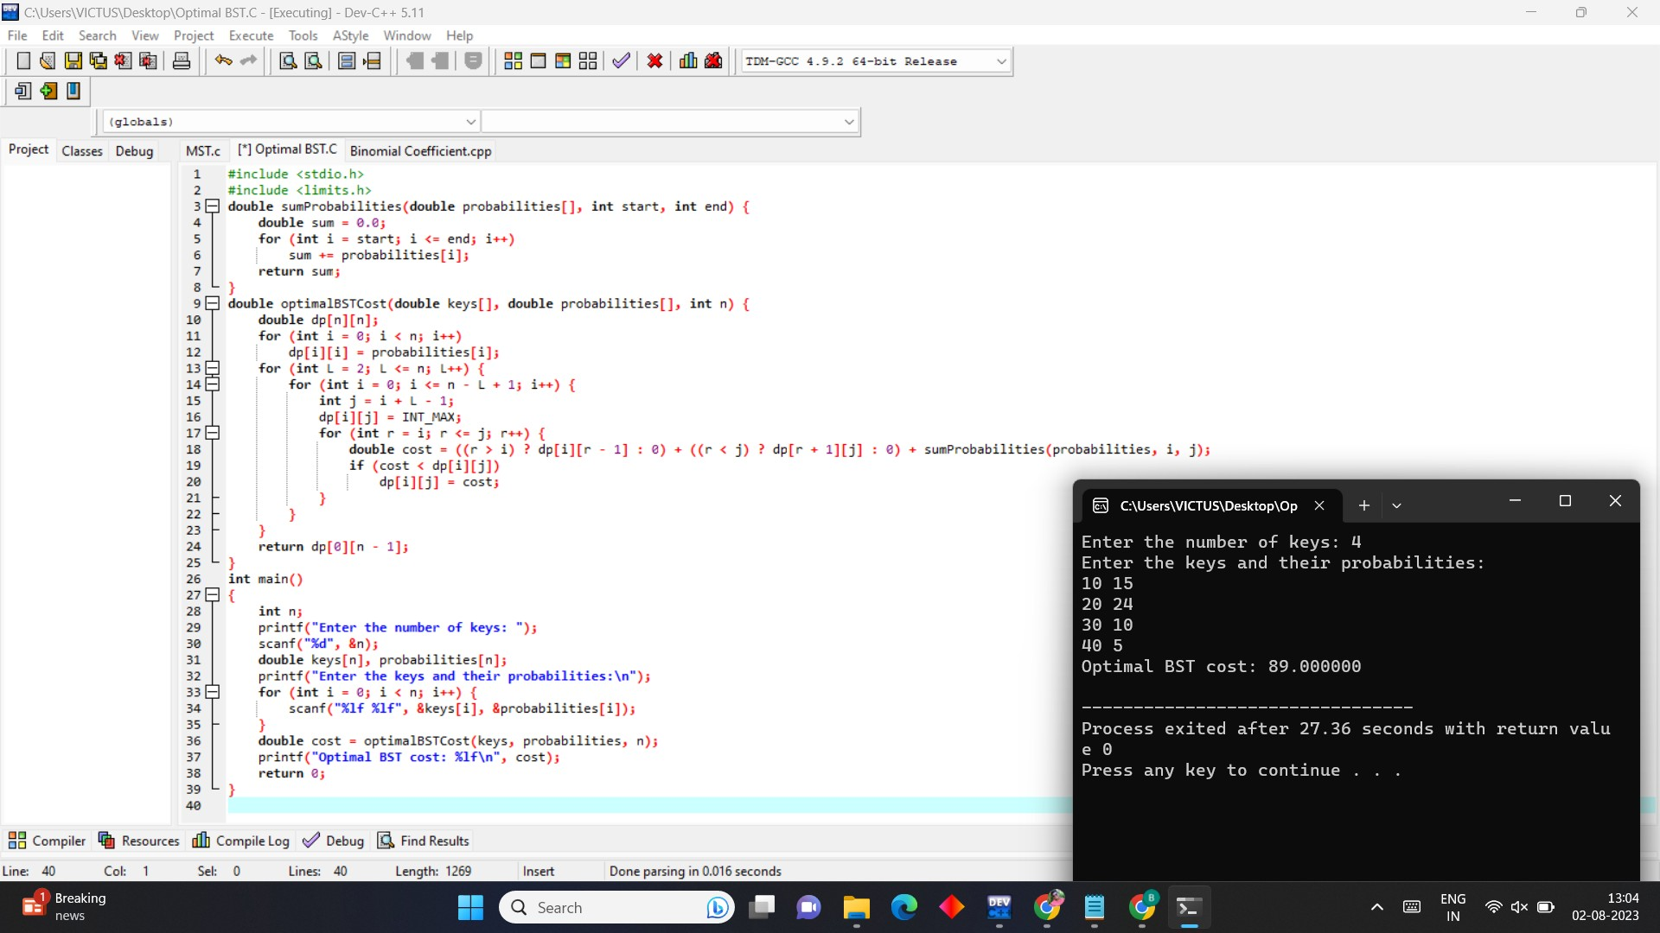

1. **Using Dynamic programming techniques to find the binomial coefficient of a given number**

**PROGRAM**

#include <stdio.h>

unsigned long long binomialCoefficient(int n, int r) { unsigned long long dp[n + 1][r + 1];

for (int i = 0; i <= n; i++) {

for (int j = 0; j <= r && j <= i; j++) { if (j == 0 || j == i)

dp[i][j] = 1; else

dp[i][j] = dp[i - 1][j - 1] + dp[i - 1][j];

}

}

return dp[n][r];

}

int main() { int n, r;

printf("Enter the value of n : "); scanf("%d", &n);

printf("Enter the value of r : "); scanf("%d", &r);

unsigned long long result = binomialCoefficient(n, r); printf("Binomial Coefficient C(%d, %d) = %llu\n", n, r, result); return 0;

}

**OUTPUT**

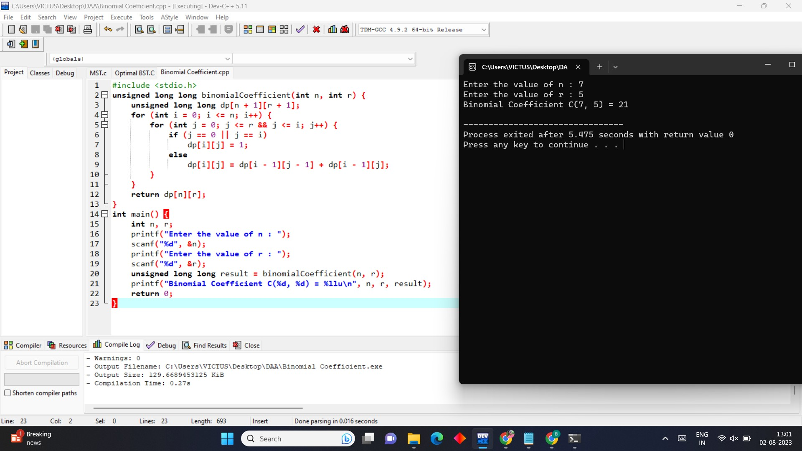

1. **Write a program to perform the Knapsack problem using greedy techniques PROGRAM**

#include <stdio.h> #include <stdlib.h> struct Item {

int weight;

int value;

};

int compare(const void* a, const void* b) { struct Item* itemA = (struct Item*)a; struct Item* itemB = (struct Item*)b;

double valuePerUnitWeightA = (double)itemA->value / itemA->weight; double valuePerUnitWeightB = (double)itemB->value / itemB->weight; if (valuePerUnitWeightA < valuePerUnitWeightB)

return 1;

else if (valuePerUnitWeightA > valuePerUnitWeightB) return -1;

else

return 0;

}

double fractionalKnapsack(int capacity, struct Item items[], int n) { qsort(items, n, sizeof(struct Item), compare);

double totalValue = 0.0; int currentWeight = 0; for (int i = 0; i < n; i++) {

if (currentWeight + items[i].weight <= capacity) { currentWeight += items[i].weight;

totalValue += items[i].value;

} else {

int remainingWeight = capacity - currentWeight;

totalValue += items[i].value * ((double)remainingWeight / items[i].weight); break;

}

}

return totalValue;

}

int main() {

int capacity = 50;

struct Item items[] = { {10, 60}, {20, 100}, {30, 120} }; int n = sizeof(items) / sizeof(items[0]);

double maxValue = fractionalKnapsack(capacity, items, n); printf("Maximum value in the knapsack: %.2f\n", maxValue); return 0;

}

**OUTPUT**

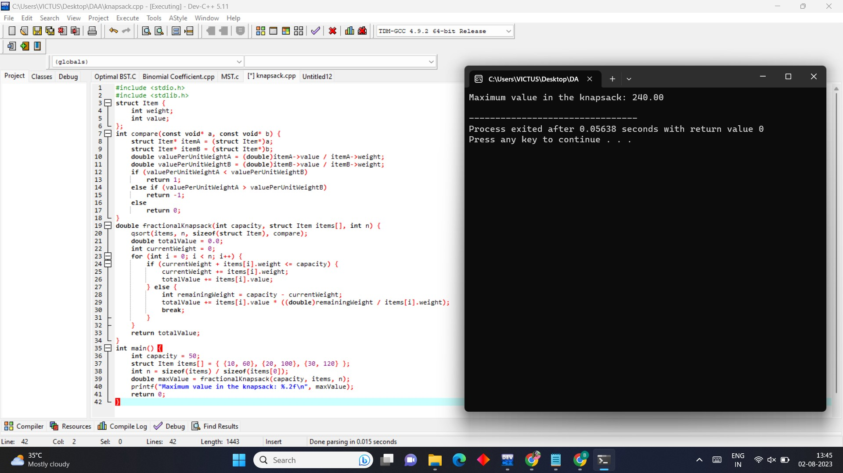

1. **Write a program to generate all the prime numbers.**

**PROGRAM**

#include <stdio.h> int main()

{

int i, j, end, isPrime;

printf("Find prime numbers between 1 to : "); scanf("%d", &end);

printf("All prime numbers between 1 to %d are:\n", end); for(i=2; i<=end; i++)

{

isPrime = 1; for(j=2; j<=i/2; j++)

{

if(i%j==0)

{

isPrime = 0; break;

}

}

if(isPrime==1)

{

printf("%d, ", i);

}

}

return 0;

}

**OUTPUT**

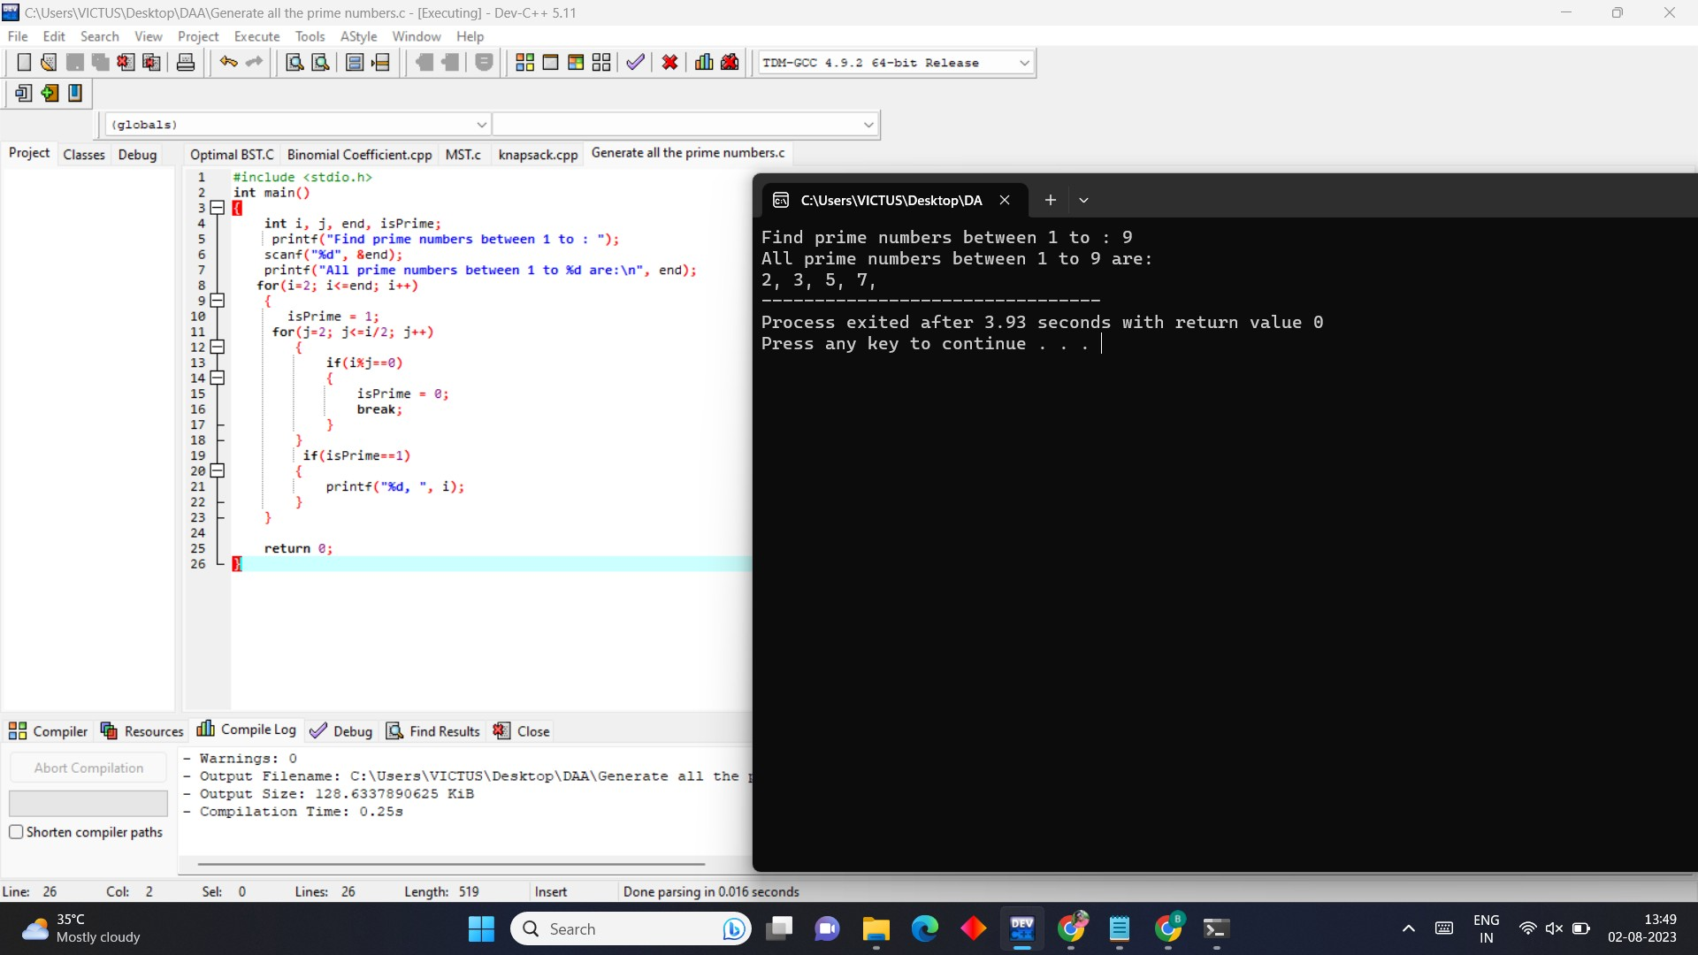

1. **Using Divide and Conquer strategy to find Max and Min values in the list. PROGRAM**

#include<stdio.h> #include<stdio.h> int max, min;

int a[100];

void maxmin(int i, int j)

{

int max1, min1, mid; if(i==j)

{

max = min = a[i];

}

else

{

if(i == j-1)

{

if(a[i] <a[j])

{

max = a[j];

min = a[i];

}

else

{

max = a[i];

min = a[j];

}

}

else

{

mid = (i+j)/2; maxmin(i, mid);

max1 = max; min1 = min; maxmin(mid+1, j);

if(max <max1) max = max1; if(min > min1) min = min1;

}

}

}

int main ()

{

int i, num;

printf ("\nEnter the total number of numbers : "); scanf ("%d",&num);

printf ("Enter the numbers : \n"); for (i=1;i<=num;i++)

scanf ("%d",&a[i]); max = a[0];

min = a[0]; maxmin(1, num);

printf ("Minimum element in an array : %d\n", min); printf ("Maximum element in an array : %d\n", max); return 0;

}

**OUTPUT**

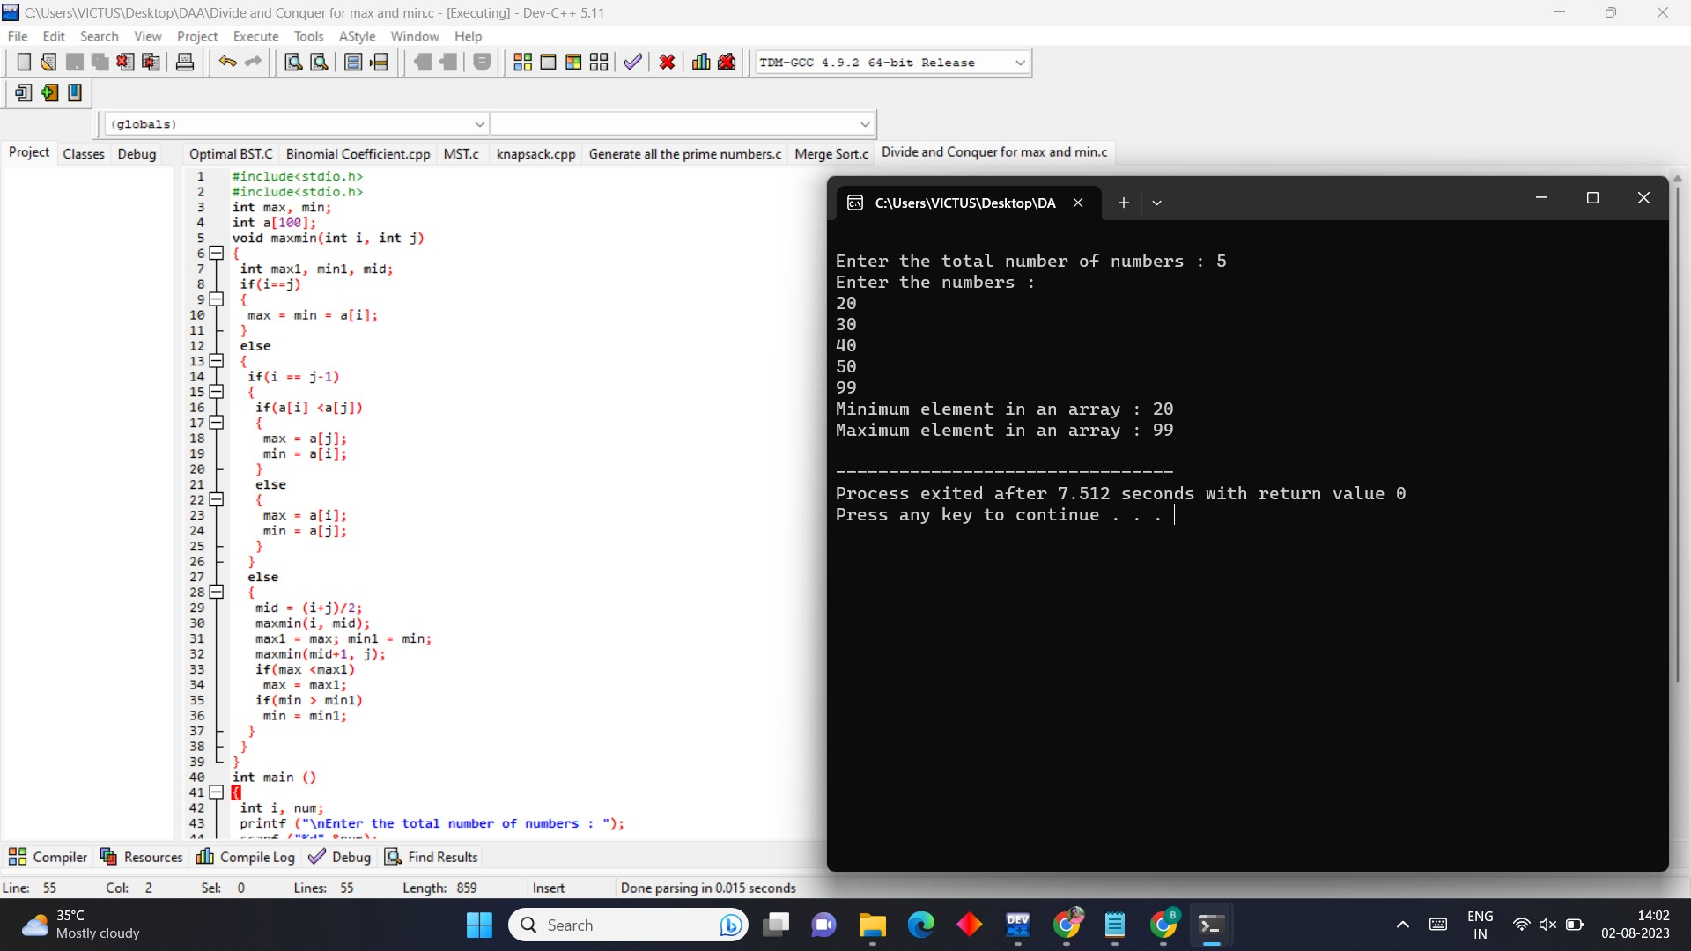

1. **Write a program to perform Merge Sort.**

**PROGRAM**

#include <stdio.h> #include <stdlib.h>

void merge(int arr[], int l, int m, int r)

{

int i, j, k;

int n1 = m - l + 1; int n2 = r - m;

int L[n1], R[n2];

for (i = 0; i < n1; i++)

L[i] = arr[l + i]; for (j = 0; j < n2; j++)

R[j] = arr[m + 1 + j];

i = 0;

j = 0;

k = l;

while (i < n1 && j < n2) {

if (L[i] <= R[j]) {

arr[k] = L[i]; i++;

}

else {

} k++;

}

arr[k] = R[j]; j++;

while (i < n1) {

arr[k] = L[i]; i++;

k++;

}

while (j < n2) {

arr[k] = R[j]; j++;

k++;

}

}

void mergeSort(int arr[], int l, int r)

{

if (l < r) {

int m = l + (r - l) / 2;

mergeSort(arr, l, m); mergeSort(arr, m + 1, r);

merge(arr, l, m, r);

}

}

void printArray(int A[], int size)

{

int i;

for (i = 0; i < size; i++)

printf("%d ", A[i]); printf("\n");

}

int main()

{

int arr[] = { 12, 11, 13, 5, 6, 7 };

int arr_size = sizeof(arr) / sizeof(arr[0]); printf("Given array is :\n"); printArray(arr, arr_size); mergeSort(arr, 0, arr_size - 1); printf("\nSorted array is \n"); printArray(arr, arr_size);

return 0;

}

**OUTPUT**

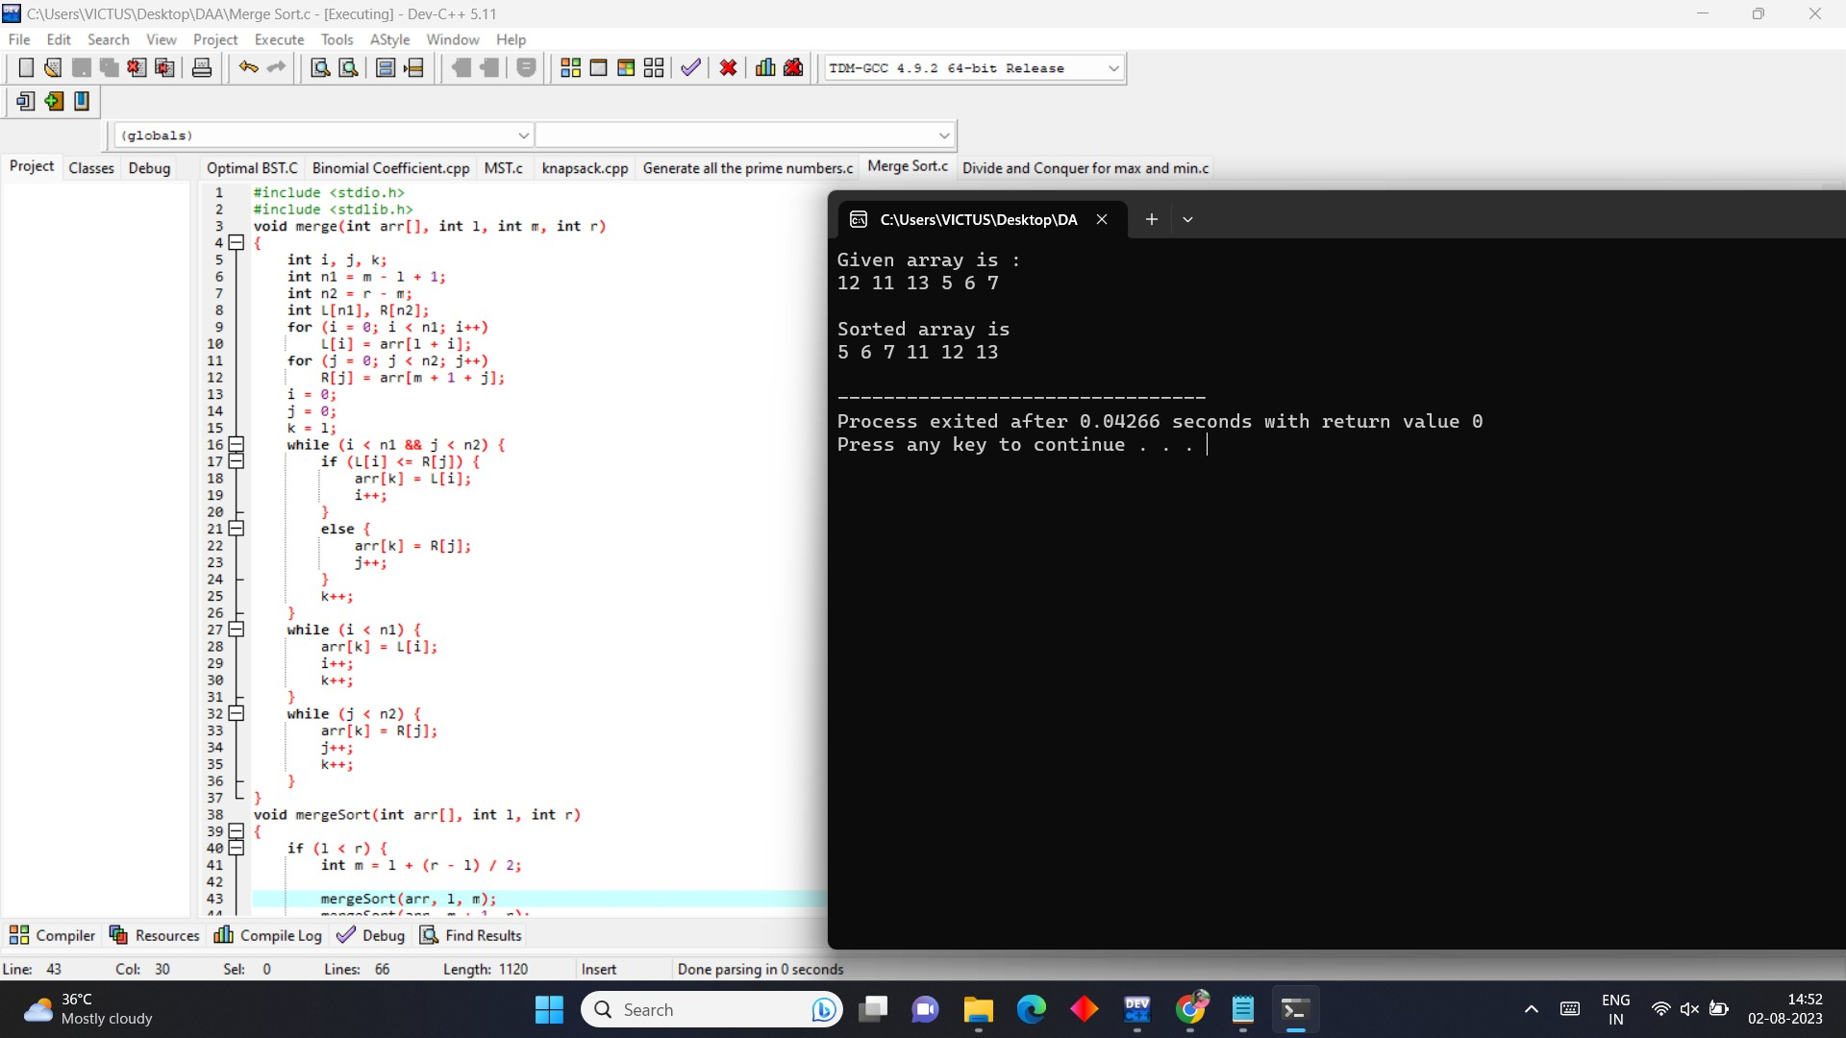

# CSA0683-DESIGN AND ANALYSIS OF ALGORITHMS FOR SEARCHING ALGORITHMS

**B.Nikhil(192111054)**

**DAY-3**

1. **Write C program to perform n Queens Problem using backtracking PROGRAM**

#include<stdio.h>

#include<math.h> int board[20],count; int main()

{

int n,i,j;

void queen(int row,int n);

printf(" - N Queens Problem Using Backtracking -"); printf("\n\nEnter number of Queens:"); scanf("%d",&n);

queen(1,n); return 0;

}

void print(int n)

{

int i,j;

printf("\n\nSolution %d:\n\n",++count); for(i=1;i<=n;++i)

printf("\t%d",i); for(i=1;i<=n;++i)

{

printf("\n\n%d",i); for(j=1;j<=n;++j)

{

if(board[i]==j) printf("\tQ"); else

printf("\t-");

}

}

}

int place(int row,int column)

{

int i;

for(i=1;i<=row-1;++i)

{

if(board[i]==column) return 0;

else

if(abs(board[i]-column)==abs(i-row)) return 0;

}

return 1;

}

void queen(int row,int n)

{

int column; for(column=1;column<=n;++column)

{

if(place(row,column))

{

board[row]=column; if(row==n)

print(n); else

queen(row+1,n);

}

}

}

## OUTPUT

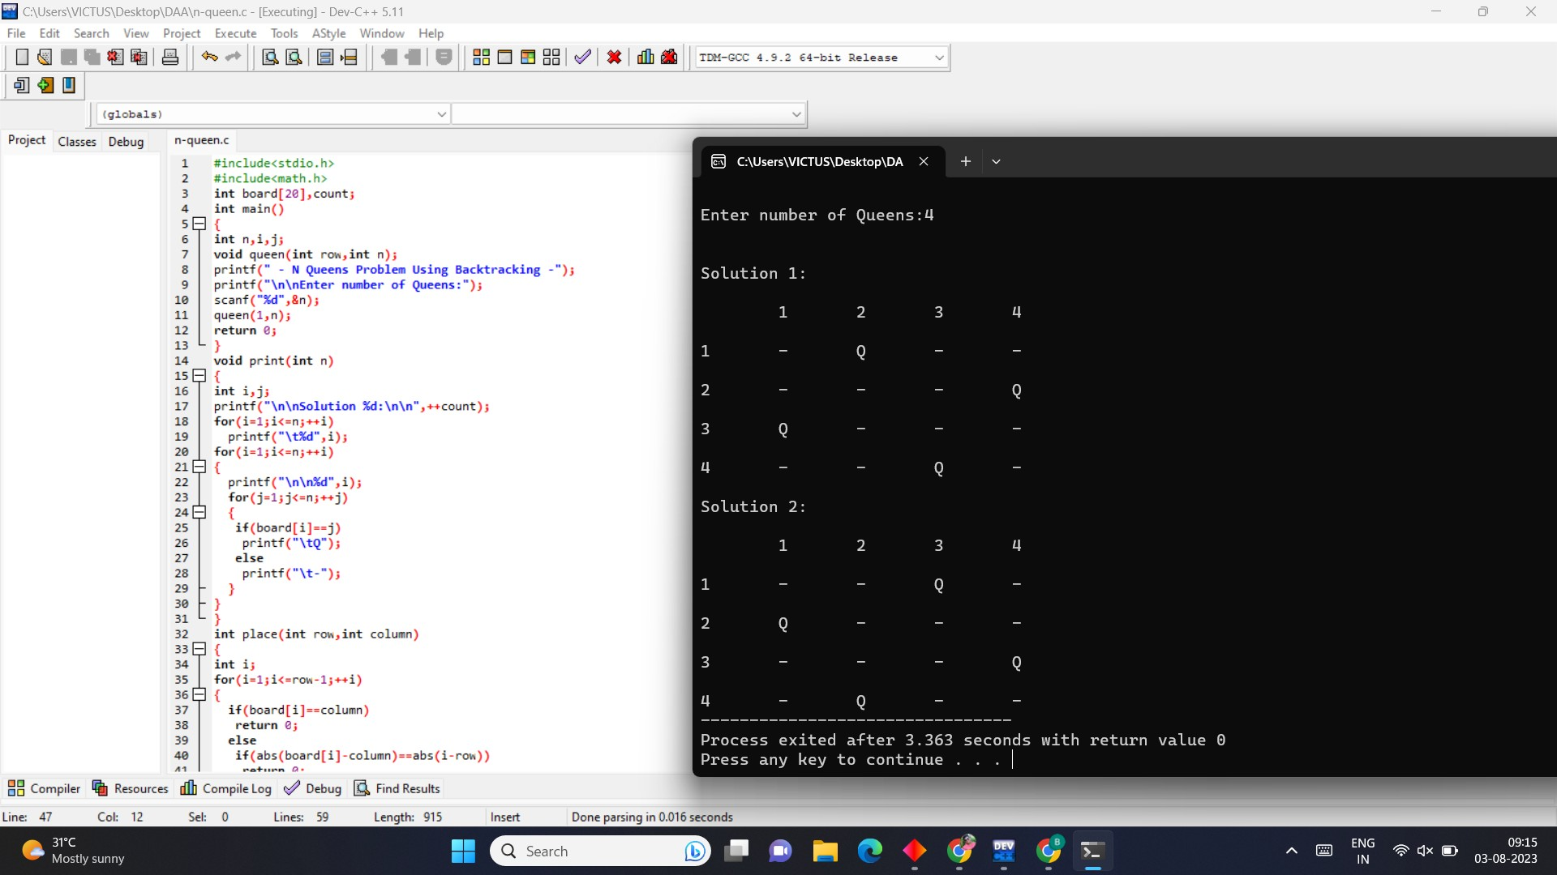

1. **Write C program to print minimum and maximum value sequence for all the numbers in a list.**

## PROGRAM

#include <stdio.h> void main()

{

int arr1[100]; int i, mx, mn, n;

printf("Input the number of elements to be stored in the array :"); scanf("%d",&n);

printf("Input %d elements in the array :\n",n); for(i=0;i<n;i++)

{

printf("element - %d : ",i);

scanf("%d",&arr1[i]);

}

mx = arr1[0]; mn = arr1[0];

for(i=1; i<n; i++)

{

if(arr1[i]>mx)

{

mx = arr1[i];

}

if(arr1[i]<mn)

{

mn = arr1[i];

}

}

printf("Maximum element is : %d\n", mx); printf("Minimum element is : %d\n\n", mn);

}

## OUTPUT

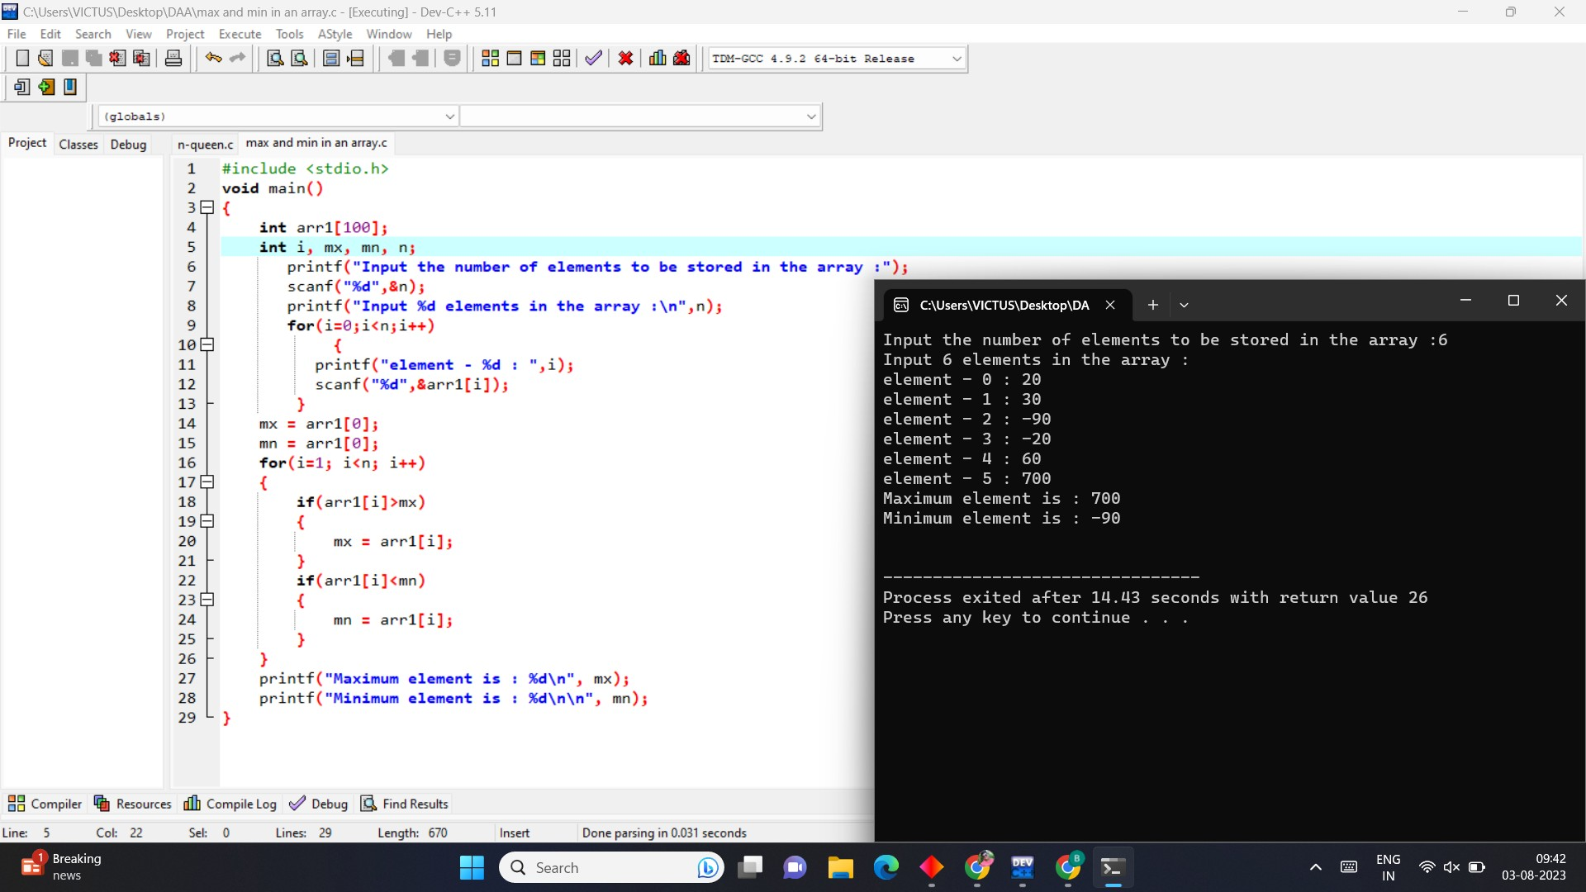

1. **Write C program to perform traveling salesman problem using dynamic programming**

## PROGRAM

#include<stdio.h>

int ary[10][10],completed[10],n,cost=0; void takeInput()

{

int i,j;

printf("Enter the number of villages: "); scanf("%d",&n);

printf("\nEnter the Cost Matrix\n"); for(i=0;i < n;i++)

{

printf("\nEnter Elements of Row: %d\n",i+1); for( j=0;j < n;j++)

scanf("%d",&ary[i][j]); completed[i]=0;

}

printf("\n\nThe cost list is:"); for( i=0;i < n;i++)

{

printf("\n"); for(j=0;j < n;j++)

printf("\t%d",ary[i][j]);

}

}

void mincost(int city)

{

int i,ncity; completed[city]=1; printf("%d--->",city+1); ncity=least(city); if(ncity==999)

{

ncity=0; printf("%d",ncity+1); cost+=ary[city][ncity]; return;

}

mincost(ncity);

}

int least(int c)

{

int i,nc=999;

int min=999,kmin; for(i=0;i < n;i++)

{

if((ary[c][i]!=0)&&(completed[i]==0))

if(ary[c][i]+ary[i][c] < min)

{

min=ary[i][0]+ary[c][i]; kmin=ary[c][i];

nc=i;

}

}

if(min!=999) cost+=kmin; return nc;

}

int main()

{

takeInput();

printf("\n\nThe Path is:\n"); mincost(0);

printf("\n\nMinimum cost is %d\n ",cost); return 0;

}

## OUTPUT

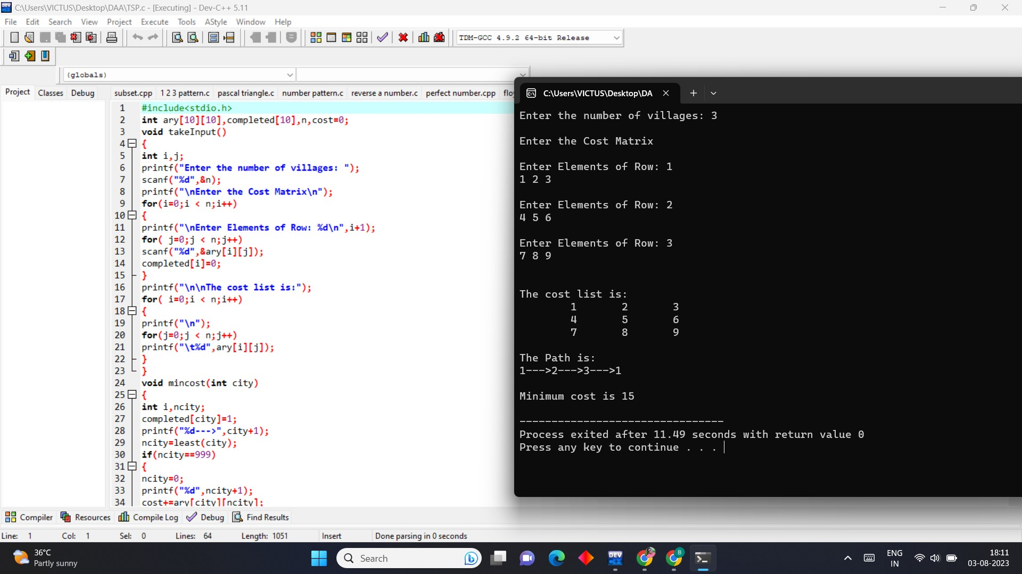

1. **Write C program for the given pattern**

**If n=4**

|  |  |  |  |
| --- | --- | --- | --- |
| **1** |  |  | |
| **1** | **2** |
| **1** | **2** | **3** |  |
| **1** | **2** | **3** | **4** |

## PROGRAM:

#include <stdio.h> int main()

{

int i, j, rows;

printf("Enter the number of rows: "); scanf("%d", &rows);

for (i = 1; i <= rows;i++)

{

for (j = 1; j <= i;j++)

{

printf("%d ", j);

}

printf("\n");

}

return 0;

}

## OUTPUT

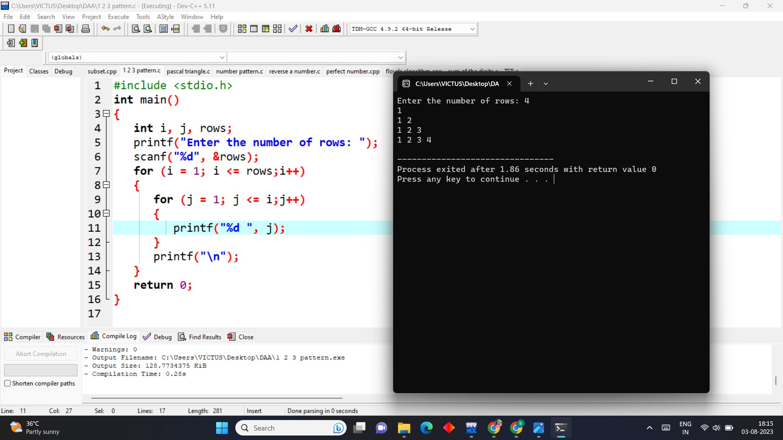

1. **Write C program to perform Floyd’s algorithm**

## PROGRAM

#include <stdio.h> #include <stdlib.h>

void floydWarshall(int **graph, int n)

{

int i, j, k;

for (k = 0; k < n; k++)

{

for (i = 0; i < n; i++)

{

for (j = 0; j < n; j++)

{

if (graph[i][j] > graph[i][k] + graph[k][j])

graph[i][j] = graph[i][k] + graph[k][j];

}

}

}

}

int main(void)

{

int n, i, j;

printf("Enter the number of vertices: "); scanf("%d", &n);

int **graph = (int **)malloc((long unsigned) n * sizeof(int *));

for (i = 0; i < n; i++)

{

graph[i] = (int *)malloc((long unsigned) n * sizeof(int));

}

for (i = 0; i < n; i++)

{

for (j = 0; j < n; j++)

{

if (i == j) graph[i][j] = 0;

else

graph[i][j] = 100;

}

}

printf("Enter the edges: \n"); for (i = 0; i < n; i++)

{

for (j = 0; j < n; j++)

{

printf("[%d][%d]: ", i, j);

scanf("%d", &graph[i][j]);

}

}

printf("The original graph is:\n"); for (i = 0; i < n; i++)

{

for (j = 0; j < n; j++)

{

printf("%d ", graph[i][j]);

}

printf("\n");

}

floydWarshall(graph, n);

printf("The shortest path matrix is:\n"); for (i = 0; i < n; i++)

{

for (j = 0; j < n; j++)

{

printf("%d ", graph[i][j]);

}

printf("\n");

}

return 0;

}

## OUTPUT

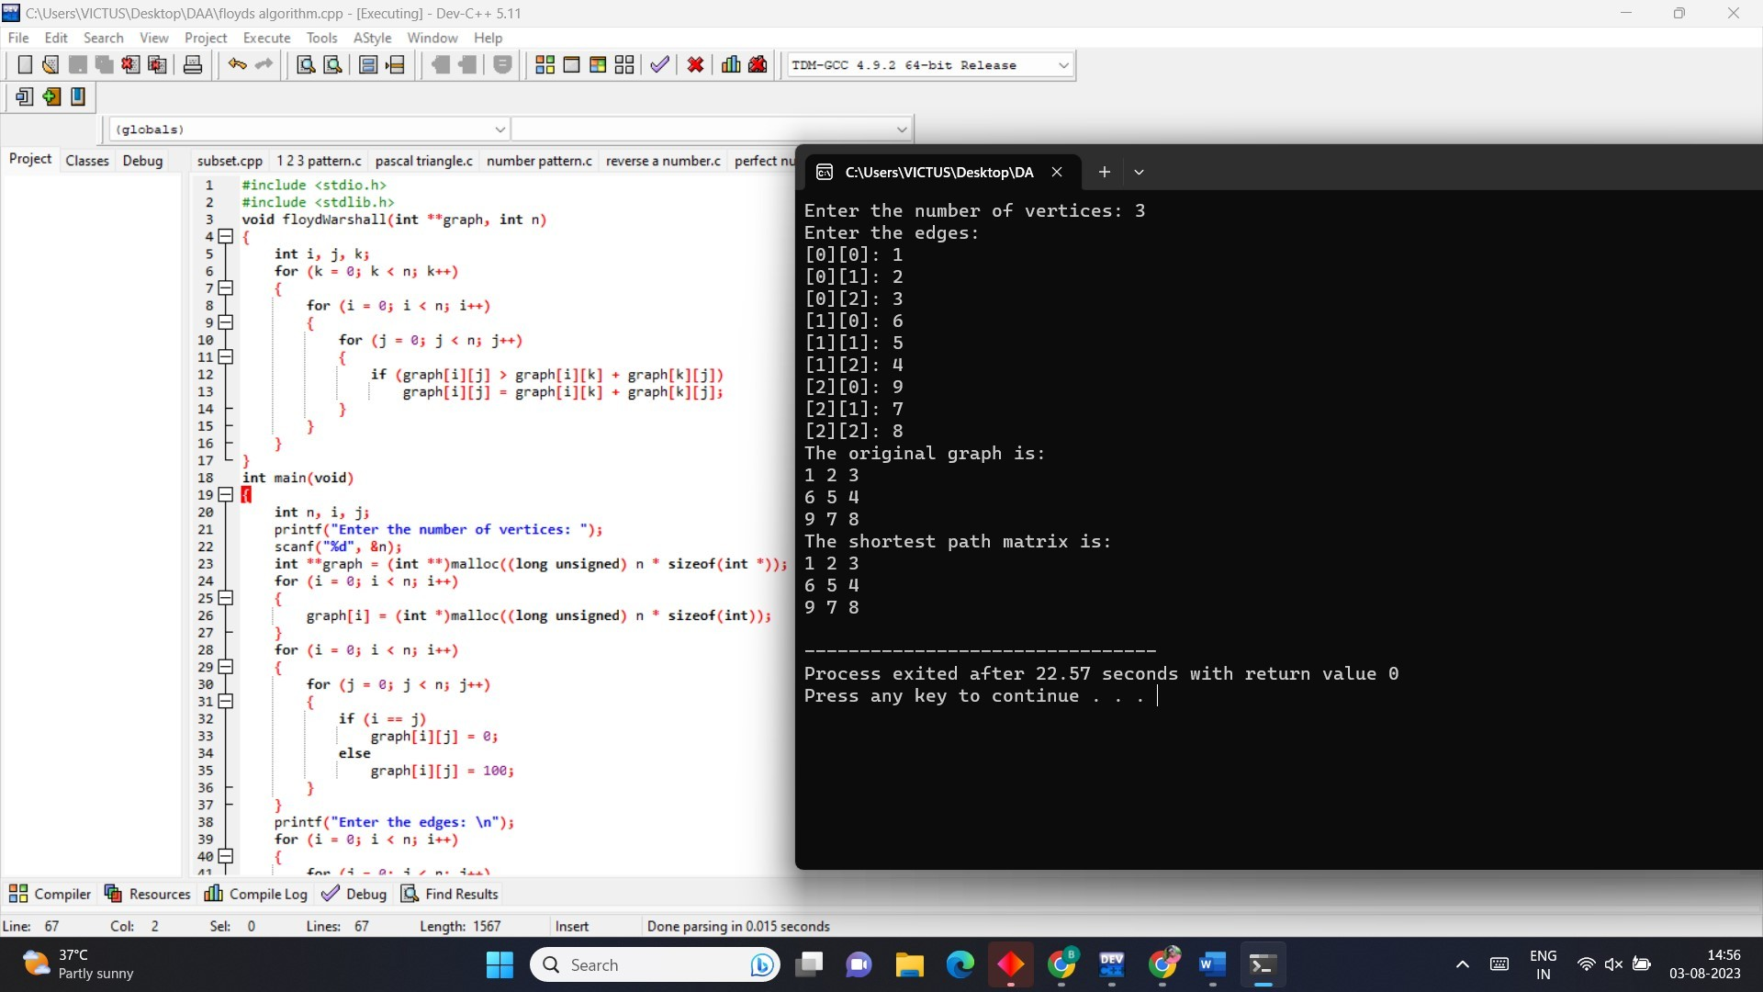

1. **Write C program for pascal triangle.**

## PROGRAM

#include <stdio.h> int main() {

int rows, coef = 1, space, i, j; printf("Enter the number of rows: "); scanf("%d", &rows);

for (i = 0; i < rows; i++) {

for (space = 1; space <= rows - i; space++) printf(" ");

for (j = 0; j <= i; j++) { if (j == 0 || i == 0)

coef = 1; else

coef = coef * (i - j + 1) / j; printf("%4d", coef);

}

printf("\n");

}

return 0;

}

## OUTPUT

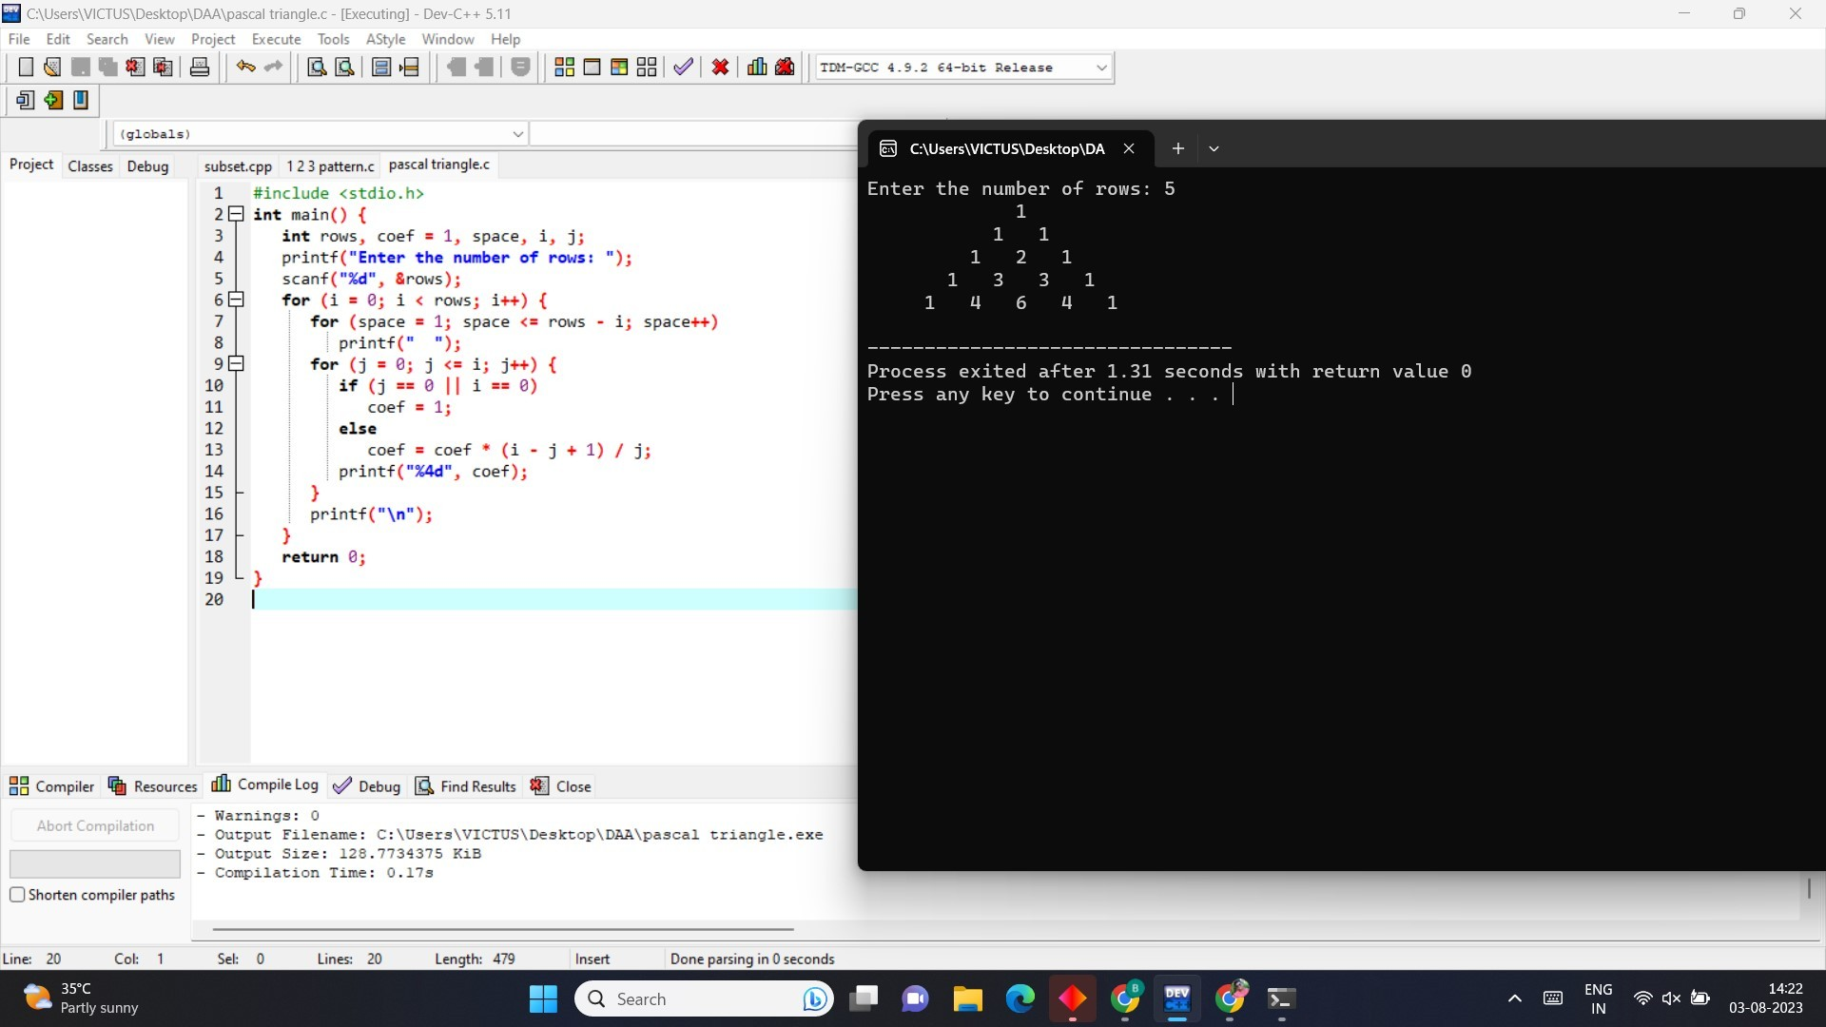

1. **Write a program to find the optimal cost by using appropriate algorithm**

## PROGRAM

#include <stdio.h> #include <limits.h> #define MAX_KEYS 10

int optimalCostBST(int keys[], int freq[], int n) { int cost[n][n];

for (int i = 0; i < n; i++) { cost[i][i] = freq[i];

}

for (int chain_len = 2; chain_len <= n; chain_len++) { for (int start = 0; start < n - chain_len + 1; start++) {

int end = start + chain_len - 1; cost[start][end] = INT_MAX;

for (int root = start; root <= end; root++) {

int left_cost = (root > start) ? cost[start][root - 1] : 0; int right_cost = (root < end) ? cost[root + 1][end] : 0; int current_cost = left_cost + right_cost + freq[root]; if (current_cost < cost[start][end]) {

cost[start][end] = current_cost;

}

}

}

}

return cost[0][n - 1];

}

int main() {

int keys[MAX_KEYS], freq[MAX_KEYS]; int n;

printf("Enter the number of keys (maximum %d): ", MAX_KEYS); scanf("%d", &n);

printf("Enter the keys in sorted order:\n"); for (int i = 0; i < n; i++) {

scanf("%d", &keys[i]);

}

printf("Enter the frequencies of the keys:\n"); for (int i = 0; i < n; i++) {

scanf("%d", &freq[i]);

}

int optimal_cost = optimalCostBST(keys, freq, n);

printf("Optimal cost of the Binary Search Tree is: %d\n", optimal_cost); return 0;

}

## OUTPUT

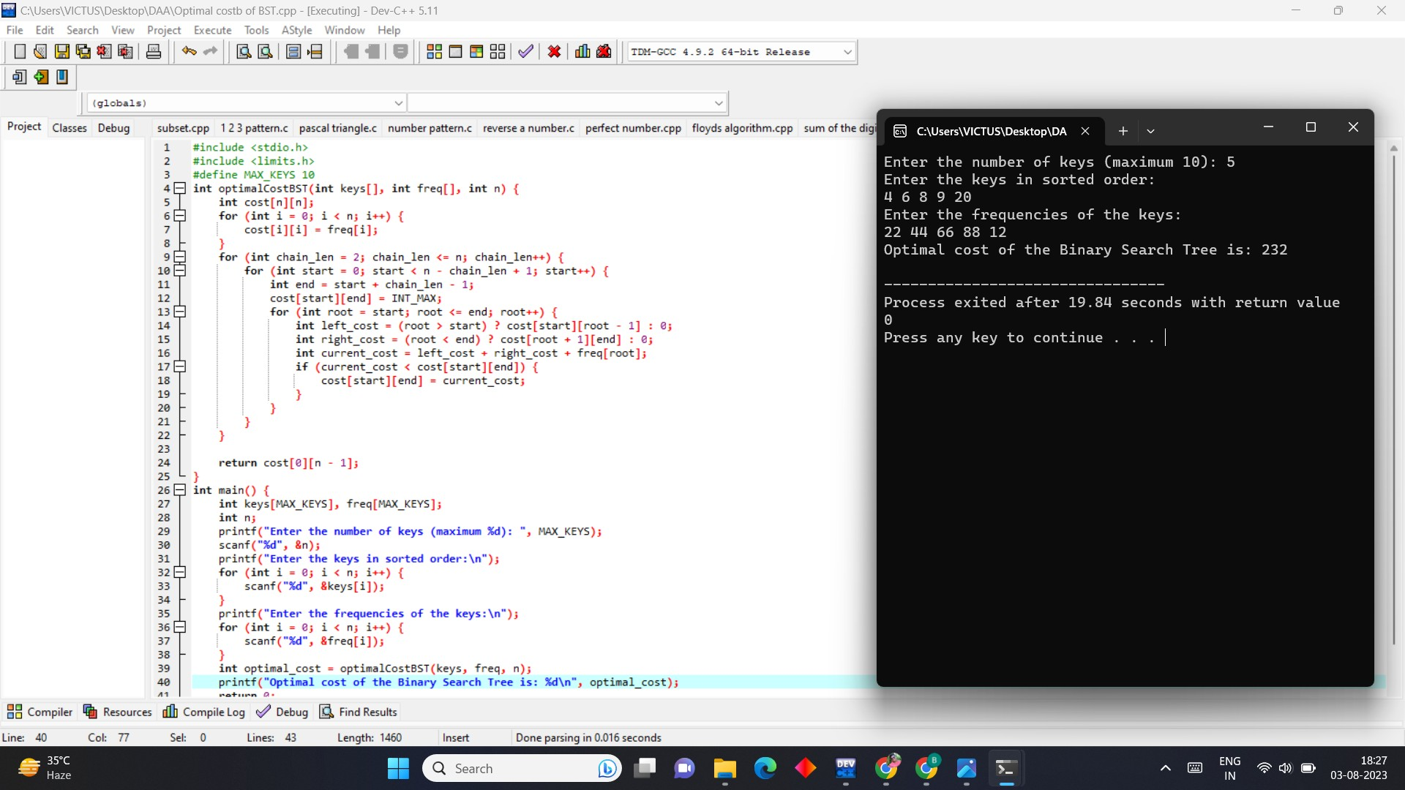

1. **Write a program to find the sum of digits. PROGRAM**

#include<stdio.h>

int main()

{

int n,sum=0,m; printf("Enter a number:"); scanf("%d",&n); while(n>0)

{ m=n%10;

sum=sum+m; n=n/10;

}

printf("Sum is=%d",sum); return 0;

}

## OUTPUT

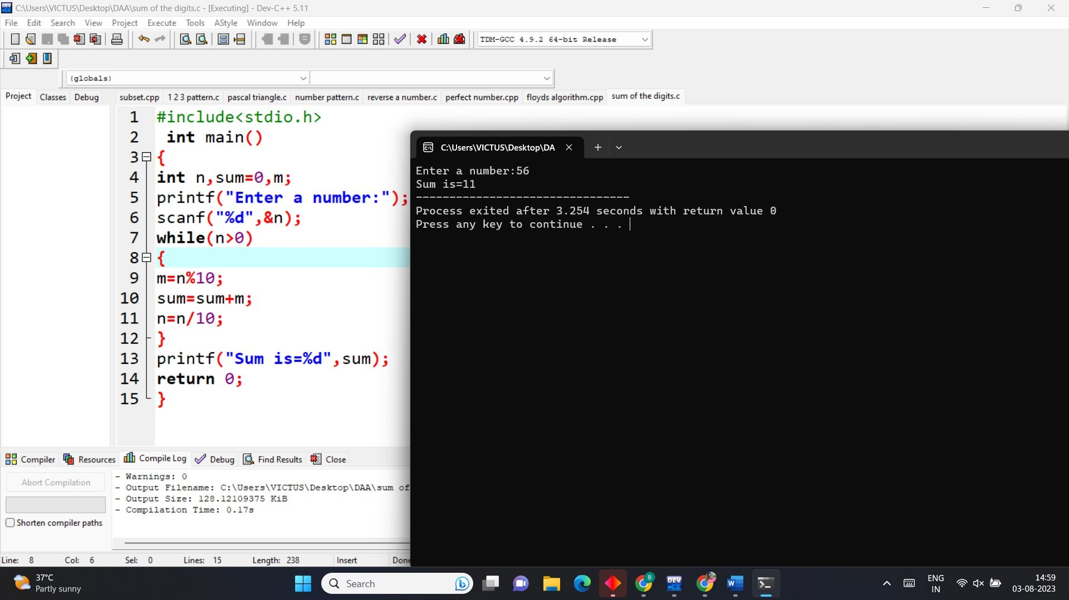

1. **Write a program to print minimum and maximum value sequency for all the numbers in a list.**

## PROGRAM

#include <stdio.h> #include <conio.h> int main()

{

int a[1000],i,n,min,max; printf("Enter size of the array : ");

scanf("%d",&n);

printf("Enter elements in array : "); for(i=0; i<n; i++)

{

scanf("%d",&a[i]);

}

min=max=a[0]; for(i=1; i<n; i++)

{

if(min>a[i])

min=a[i];

if(max<a[i])

max=a[i];

}

printf("minimum of array is : %d",min); printf("\nmaximum of array is : %d",max);

return 0;

}

## OUTPUT

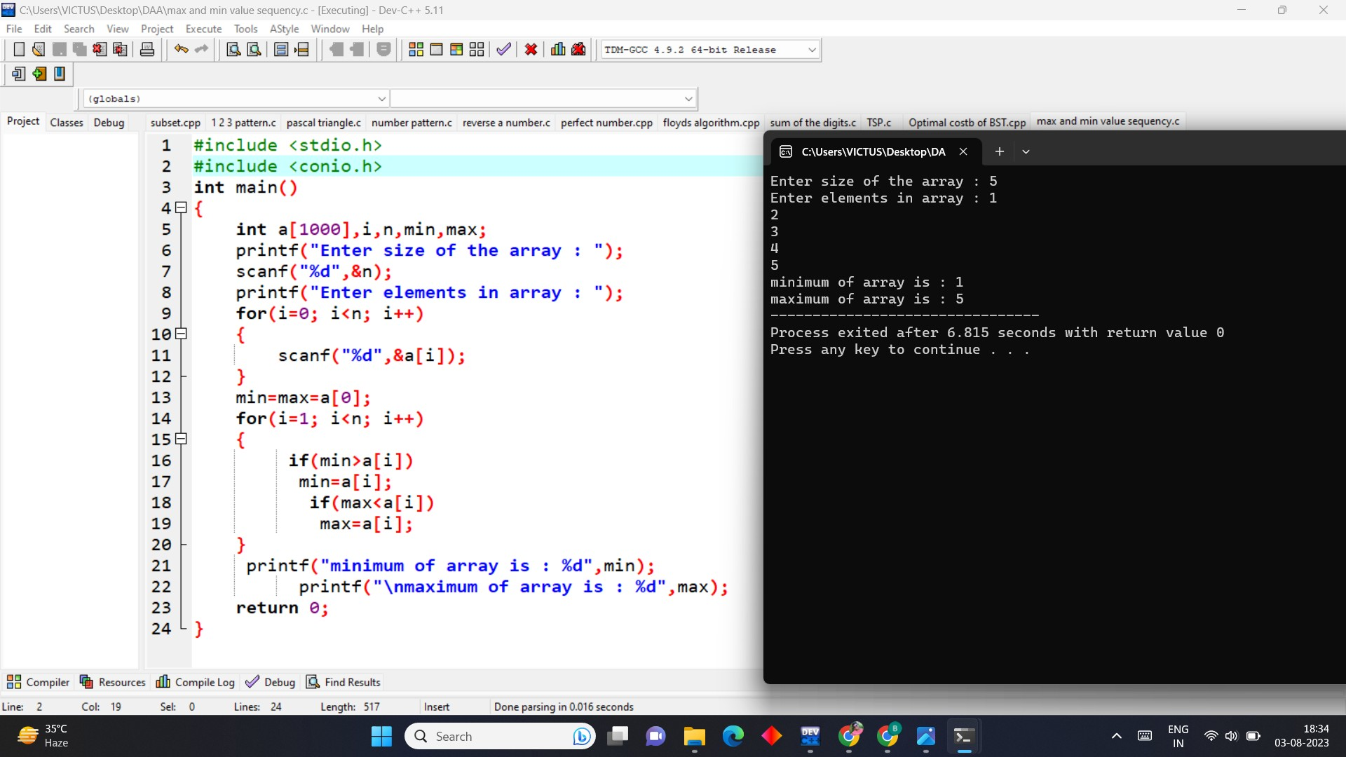

1. **Write a program to perform n Queens Problem using backtracking. PROGRAM**

#include<stdio.h> #include<math.h> int board[20],count;

int main()

{

int n,i,j;

void queen(int row,int n);

printf(" - N Queens Problem Using Backtracking -"); printf("\n\nEnter number of Queens:"); scanf("%d",&n);

queen(1,n); return 0;

}

void print(int n)

{

int i,j;

printf("\n\nSolution %d:\n\n",++count); for(i=1;i<=n;++i)

printf("\t%d",i); for(i=1;i<=n;++i)

{

printf("\n\n%d",i); for(j=1;j<=n;++j)

{

if(board[i]==j) printf("\tQ"); else

printf("\t-");

}

}

}

int place(int row,int column)

{

int i;

for(i=1;i<=row-1;++i)

{

if(board[i]==column) return 0;

else

if(abs(board[i]-column)==abs(i-row)) return 0;

}

return 1;

}

void queen(int row,int n)

{

int column;

for(column=1;column<=n;++column)

{

if(place(row,column))

{

board[row]=column; if(row==n)

print(n); else

queen(row+1,n);

}

}

}

**OUTPUT**

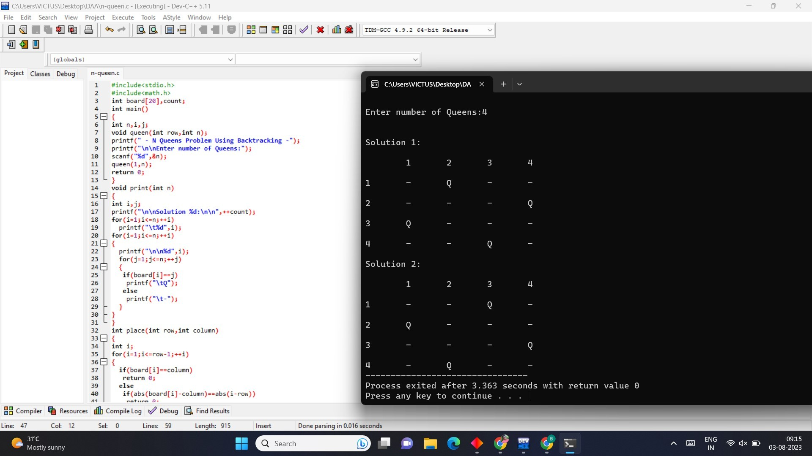

# CSA0683-DESIGN AND ANALYSIS OF ALGORITHMS FOR SEARCHING ALGORITHMS

**B.Nikhil(192111054)**

**DAY-4**

1. **Write C program to insert a number in a list. PROGRAM**

#include<stdio.h> int main()

{

int student[40],pos,i,size,value;

printf("enter no of elements in array of students:"); scanf("%d",&size);

printf("enter %d elements are:\n",size); for(i=0;i<size;i++)

scanf("%d",&student[i]);

printf("enter the position where you want to insert the element:"); scanf("%d",&pos);

printf("enter the value into that position:"); scanf("%d",&value);

for(i=size-1;i>=pos-1;i--) student[i+1]=student[i];

student[pos-1]= value;

printf("final array after inserting the value is\n"); for(i=0;i<=size;i++)

printf(" %d ",student[i]); return 0;

}

**OUTPUT**

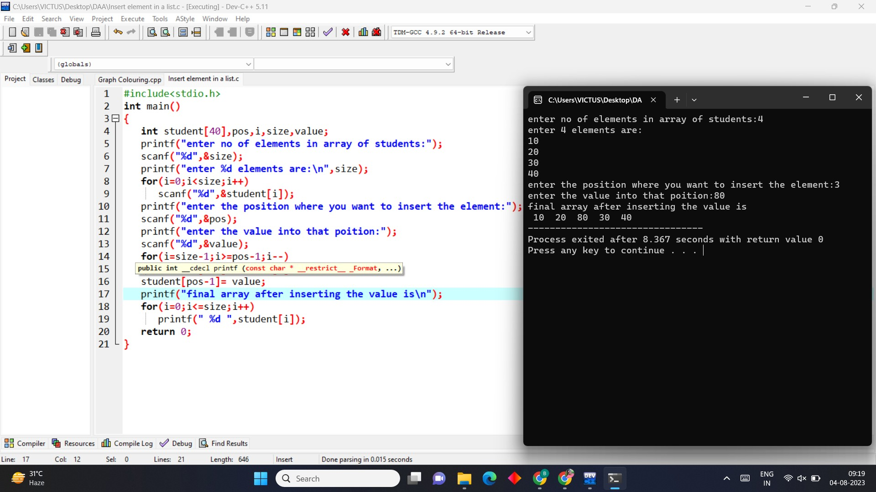

1. **Write C program to perform a sum of subsets problem using backtracking.**

**PROGRAM**

#include <stdio.h> #include <stdbool.h>

void generateSubsets(int arr[], int n, bool subset[], int index, int targetSum, int currentSum) { if (index == n) {

if (currentSum == targetSum) {

printf("Subset with target sum %d: {", targetSum); for (int i = 0; i < n; i++) {

if (subset[i]) {

printf(" %d", arr[i]);

}

}

printf(" }\n");

}

return;

}

subset[index] = true;

generateSubsets(arr, n, subset, index + 1, targetSum, currentSum + arr[index]); subset[index] = false;

generateSubsets(arr, n, subset, index + 1, targetSum, currentSum);

}

int main() { int n;

printf("Enter the number of elements: "); scanf("%d", &n);

int arr[n];

printf("Enter the elements:\n");

for (int i = 0; i < n; i++) { scanf("%d", &arr[i]);

}

int targetSum;

printf("Enter the target sum: "); scanf("%d", &targetSum); bool subset[n];

generateSubsets(arr, n, subset, 0, targetSum, 0);

return 0;

}

**OUTPUT**

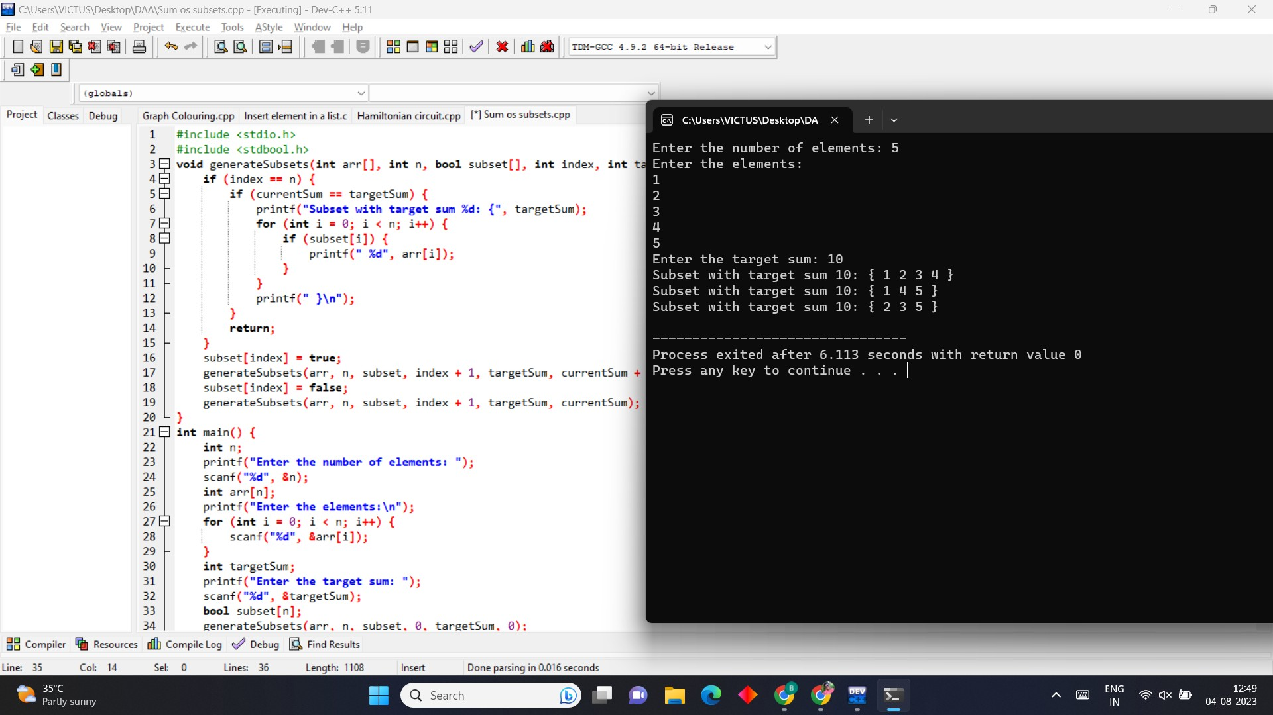

1. **Write C program to perform graph colouring problem using backtracking. PROGRAM**

#include <stdio.h> #include <stdbool.h>

#define MAX_VERTICES 20

void printSolution(int colors[], int num_vertices);

bool isSafe(int vertex, int graph[][MAX_VERTICES], int colors[], int num_vertices, int color) { for (int i = 0; i < num_vertices; i++) {

if (graph[vertex][i] && colors[i] == color) { return false;

}

}

return true;

}

bool graphColoringUtil(int graph[][MAX_VERTICES], int num_vertices, int m, int colors[], int vertex) {

if (vertex == num_vertices) { return true;

}

for (int color = 1; color <= m; color++) {

if (isSafe(vertex, graph, colors, num_vertices, color)) { colors[vertex] = color;

if (graphColoringUtil(graph, num_vertices, m, colors, vertex + 1)) { return true;

}

colors[vertex] = 0;

}

}

return false;

}

bool graphColoring(int graph[][MAX_VERTICES], int num_vertices, int m) { int colors[MAX_VERTICES];

for (int i = 0; i < num_vertices; i++) { colors[i] = 0;

}

if (!graphColoringUtil(graph, num_vertices, m, colors, 0)) { return false;

}

printf("Graph can be colored using %d colors.\n", m); printf("Coloring of vertices:\n");

printSolution(colors, num_vertices); return true;

}

void printSolution(int colors[], int num_vertices) { for (int i = 0; i < num_vertices; i++) {

printf("Vertex %d: Color %d\n", i, colors[i]);

}

}

int main() {

int num_vertices, m;

printf("Enter the number of vertices (max %d): ", MAX_VERTICES); scanf("%d", &num_vertices);

int graph[MAX_VERTICES][MAX_VERTICES];

printf("Enter the adjacency matrix for the graph:\n"); for (int i = 0; i < num_vertices; i++) {

for (int j = 0; j < num_vertices; j++) { scanf("%d", &graph[i][j]);

}

}

printf("Enter the number of colors: "); scanf("%d", &m);

if (m < 1) {

printf("Number of colors should be at least 1.\n"); return 1;

}

if (!graphColoring(graph, num_vertices, m)) {

printf("Graph cannot be colored with the given constraints.\n");

}

return 0;

}

**OUTPUT**

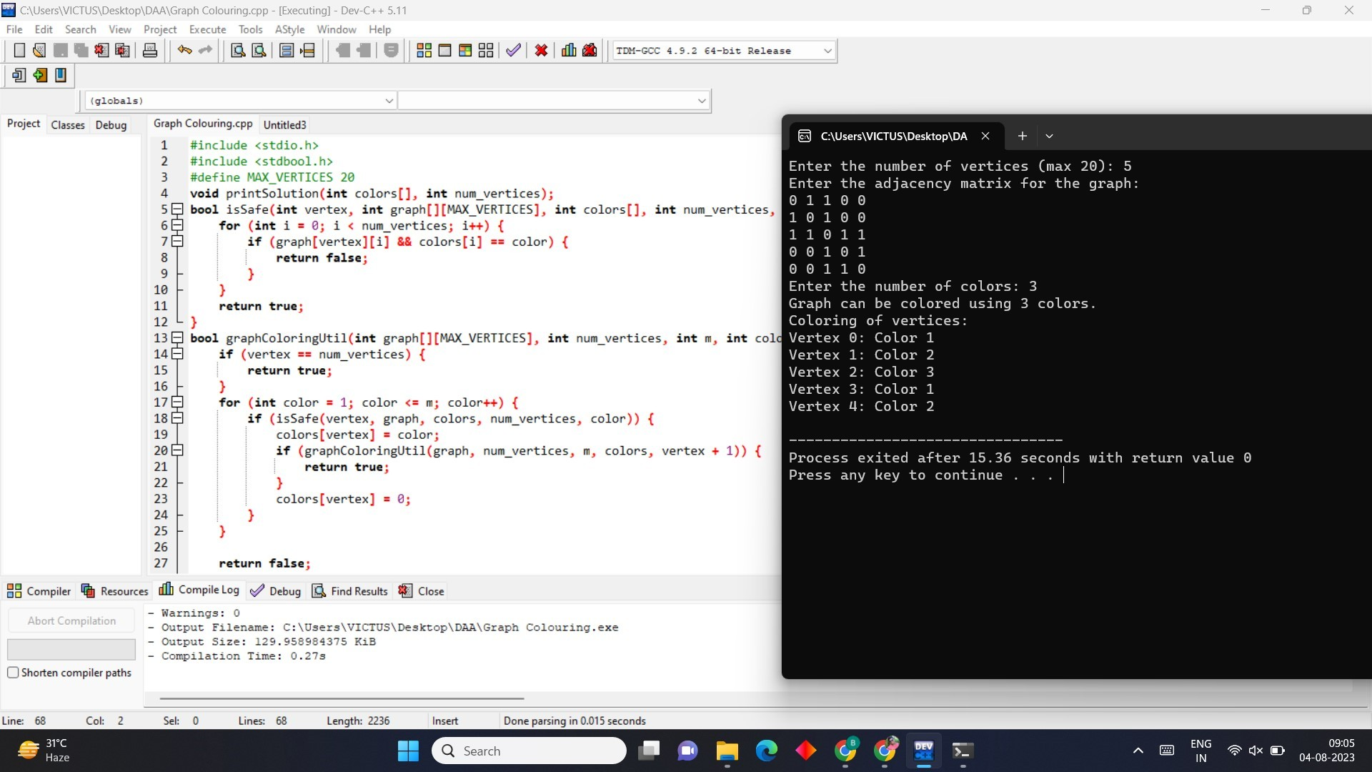

1. **Write C program to compute container loader Problem. PROGRAM**

#include <stdio.h>

#define MAX_CONTAINERS 100

#define MAX_ITEMS 100

void containerLoading(int containers[], int numContainers, int items[], int numItems) { int capacity[MAX_CONTAINERS];

for (int i = 0; i < numContainers; i++) { capacity[i] = containers[i];

}

for (int i = 0; i < numItems; i++) { int item = items[i];

int j;

for (j = 0; j < numContainers; j++) {

if (capacity[j] >= item) {

printf("Item %d fits in Container %d\n", item, j + 1); capacity[j] -= item;

break;

}

}

if (j == numContainers) {

printf("Item %d cannot be fit into any container. It exceeds the capacity.\n", item);

}

}

}

int main() {

int containers[MAX_CONTAINERS]; int numContainers;

printf("Enter the number of containers: "); scanf("%d", &numContainers);

printf("Enter the capacities of %d containers:\n", numContainers); for (int i = 0; i < numContainers; i++) {

scanf("%d", &containers[i]);

}

int items[MAX_ITEMS]; int numItems;

printf("Enter the number of items: "); scanf("%d", &numItems);

printf("Enter the sizes of %d items:\n", numItems); for (int i = 0; i < numItems; i++) {

scanf("%d", &items[i]);

}

printf("\nContainer Loading Result:\n"); containerLoading(containers, numContainers, items, numItems); return 0;

}

## OUTPUT

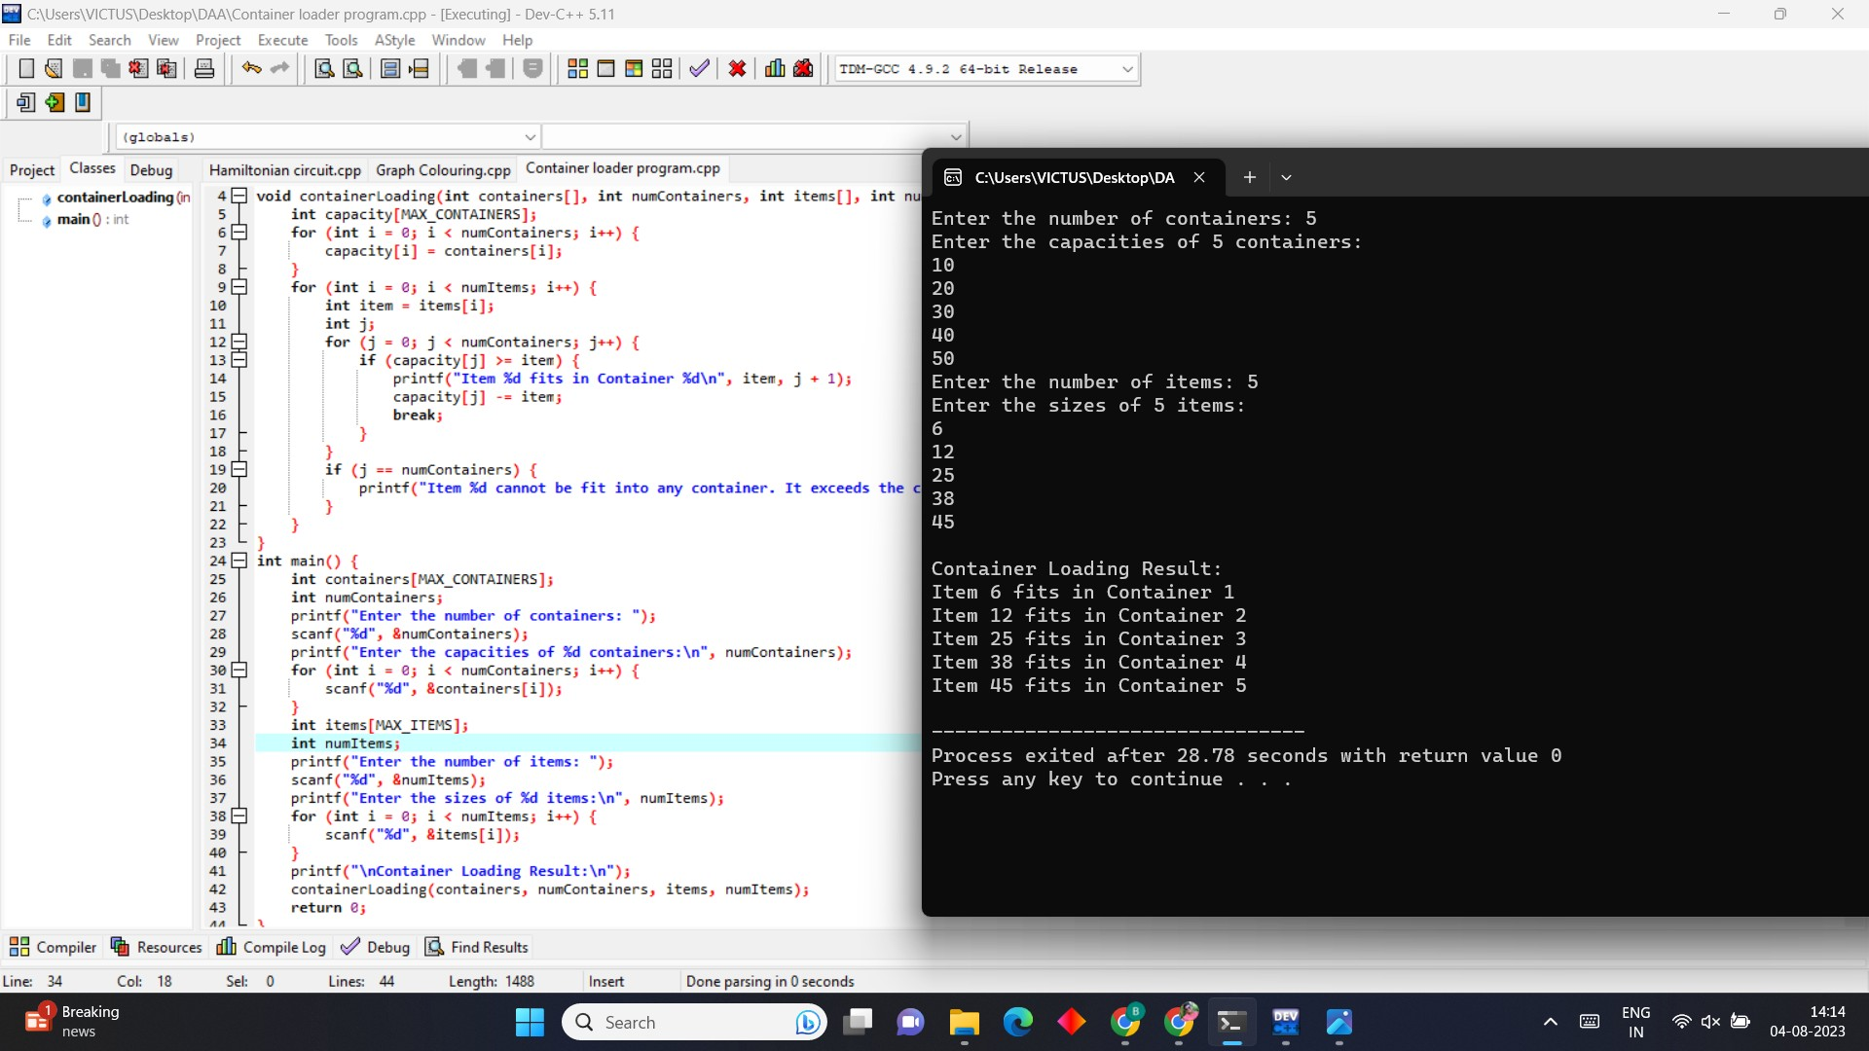

1. **Write a program to generate the list of all factors for n value.**

## PROGRAM

#include <stdio.h> int main()

{

int i, num;

printf("Enter any number to find its factor: "); scanf("%d", &num);

printf("All factors of %d are: \n", num); for(i=1; i<=num; i++)

{

if(num % i == 0)

{

printf("%d, ",i);

}

}

return 0;

}

## OUTPUT

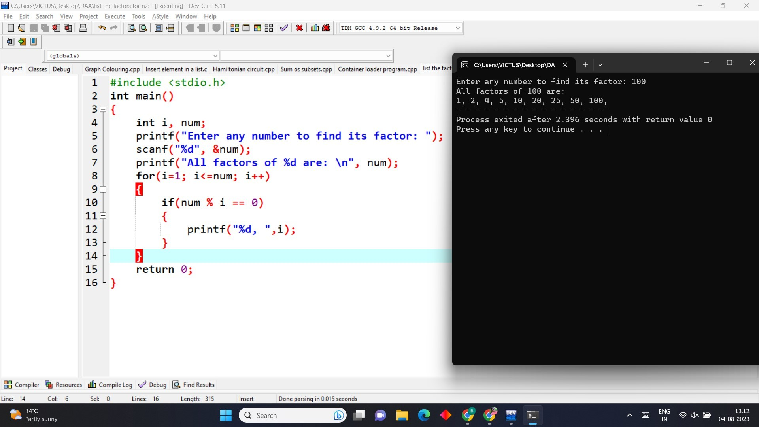

1. **Write a program to perform Assignment problem using branch and bound**

## PROGRAM

#include <stdio.h> #include <stdbool.h> #define MAX_SIZE 100

#define INF 9999 int numWorkers; int numJobs;

int costMatrix[MAX_SIZE][MAX_SIZE]; bool assigned[MAX_SIZE];

int minCost = INF;

int finalAssignment[MAX_SIZE]; void printAssignment() {

printf("Optimal Assignment:\n");

for (int i = 0; i < numWorkers; i++) {

printf("Worker %d -> Job %d\n", i + 1, finalAssignment[i] + 1);

}

}

void updateMinCost(int assignment[MAX_SIZE]) { int totalCost = 0;

for (int i = 0; i < numWorkers; i++) { totalCost += costMatrix[i][assignment[i]];

}

if (totalCost < minCost) {

minCost = totalCost;

for (int i = 0; i < numWorkers; i++) { finalAssignment[i] = assignment[i];

}

}

}

void branchAndBound(int worker, int currentCost, int assignment[MAX_SIZE]) { if (worker == numWorkers) {

updateMinCost(assignment); return;

}

for (int job = 0; job < numJobs; job++) { if (!assigned[job]) {

int newCost = currentCost + costMatrix[worker][job];

if (newCost < minCost) { assigned[job] = true; assignment[worker] = job;

branchAndBound(worker + 1, newCost, assignment);

assigned[job] = false;

}

}

}

}

int main() {

printf("Enter the number of workers: "); scanf("%d", &numWorkers); printf("Enter the number of jobs: "); scanf("%d", &numJobs);

printf("Enter the cost matrix (%d x %d):\n", numWorkers, numJobs); for (int i = 0; i < numWorkers; i++) {

for (int j = 0; j < numJobs; j++) { scanf("%d", &costMatrix[i][j]);

}

}

int assignment[MAX_SIZE];

for (int i = 0; i < numWorkers; i++) { assigned[i] = false;

}

branchAndBound(0, 0, assignment); printf("Minimum Cost: %d\n", minCost); printAssignment();

return 0;

}

## OUTPUT

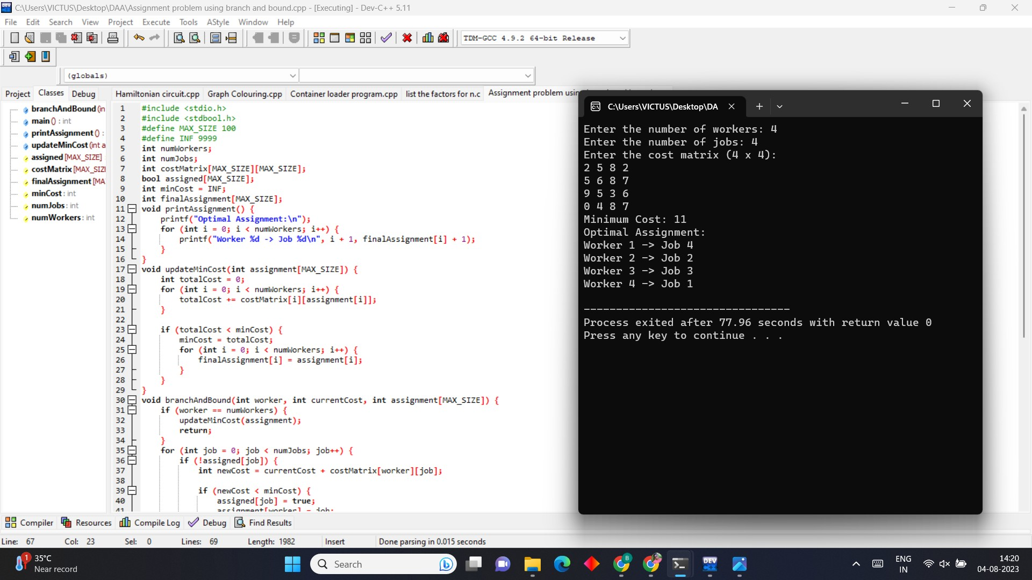

1. **Write a program to perform linear search. PROGRAM**

#include <stdio.h> int main()

{

int array[100], search, c, n;

printf("Enter number of elements in array\n"); scanf("%d", &n);

printf("Enter %d integer(s)\n", n); for (c = 0; c < n; c++) scanf("%d", &array[c]);

printf("Enter a number to search\n"); scanf("%d", &search);

for (c = 0; c < n; c++)

{

if (array[c] == search)

{

printf("%d is present at location %d.\n", search, c+1); break;

}

}

if (c == n)

printf("%d isn't present in the array.\n", search); return 0;

}

## OUTPUT

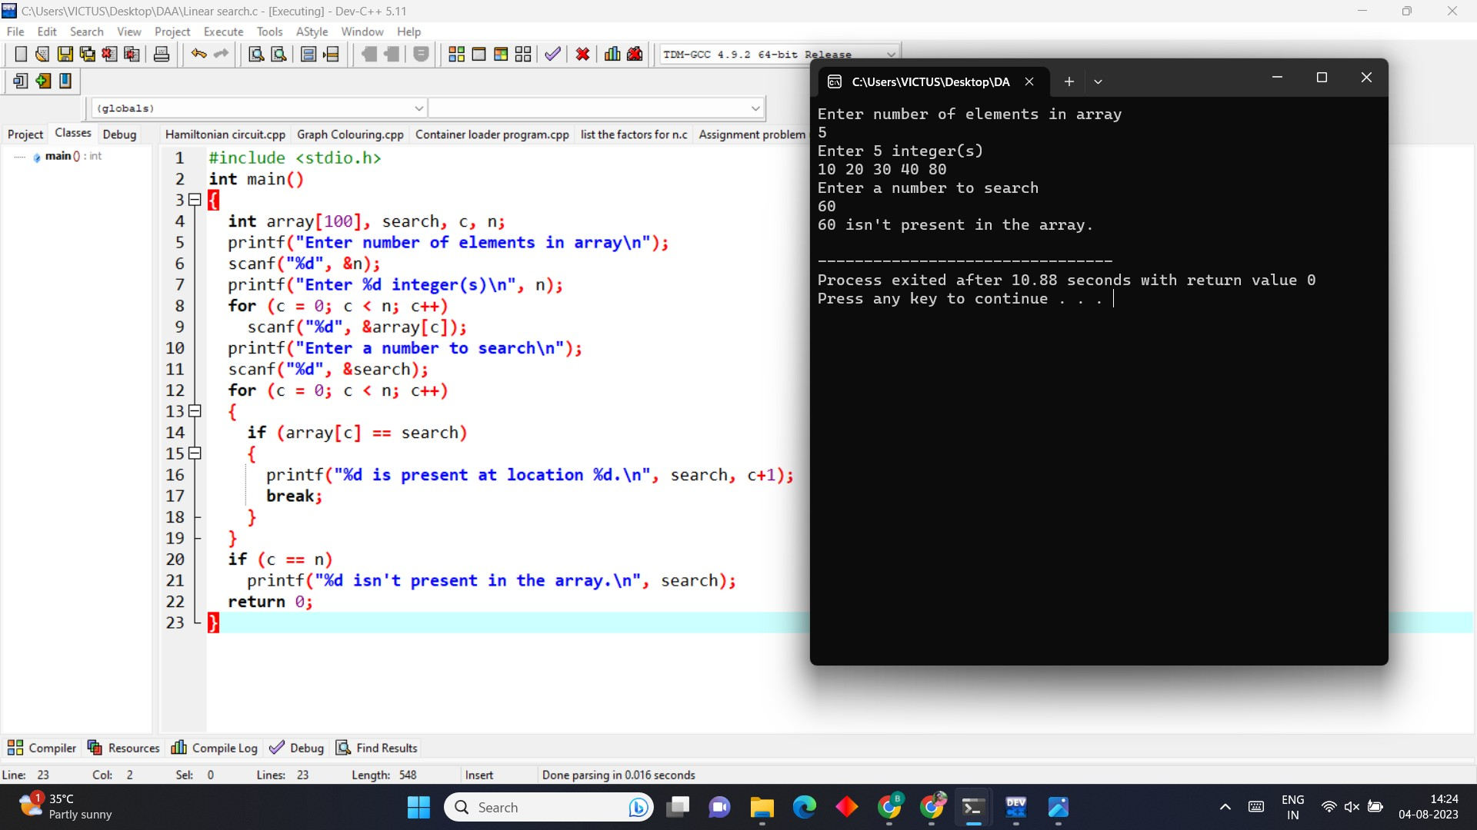

1. **Write a program to find out Hamiltonian circuit Using backtracking method PROGRAM**

#include <stdio.h> #include <stdbool.h>

#define MAX_VERTICES 100

int graph[MAX_VERTICES][MAX_VERTICES];

int numVertices;

int hamiltonianPath[MAX_VERTICES];

bool isSafe(int v, int pos, int path[MAX_VERTICES]) { if (graph[path[pos - 1]][v] == 0) {

return false;

}

for (int i = 0; i < pos; i++) { if (path[i] == v) {

return false;

}

}

return true;

}

bool hamiltonianUtil(int path[MAX_VERTICES], int pos) { if (pos == numVertices) {

if (graph[path[pos - 1]][path[0]] == 1) { return true;

}

return false;

}

for (int v = 1; v < numVertices; v++) { if (isSafe(v, pos, path)) {

path[pos] = v;

if (hamiltonianUtil(path, pos + 1)) { return true;

}

path[pos] = -1;

}

}

return false;

}

bool hamiltonianCircuit() {

int path[MAX_VERTICES];

for (int i = 0; i < numVertices; i++) { path[i] = -1;

}

path[0] = 0;

if (hamiltonianUtil(path, 1)) {

for (int i = 0; i < numVertices; i++) { hamiltonianPath[i] = path[i];

}

hamiltonianPath[numVertices] = path[0]; return true;

}

return false;

}

int main() {

printf("Enter the number of vertices in the graph: "); scanf("%d", &numVertices);

printf("Enter the adjacency matrix of the graph (1 if there's an edge, 0 otherwise):\n"); for (int i = 0; i < numVertices; i++) {

for (int j = 0; j < numVertices; j++) { scanf("%d", &graph[i][j]);

}

}

if (hamiltonianCircuit()) { printf("Hamiltonian Circuit Found:\n"); for (int i = 0; i <= numVertices; i++) {

printf("%d ", hamiltonianPath[i]);

}

printf("\n");

} else {

printf("Hamiltonian Circuit Not Found.\n");

}

return 0;

}

**OUTPUT**

